**1.Create a windows instance with volume less than 30GB.**

1. Go to the EC2 service in the AWS console.

2.From the EC2 console dashboard, in the Launch Instance box,

choose **Launch instance.**

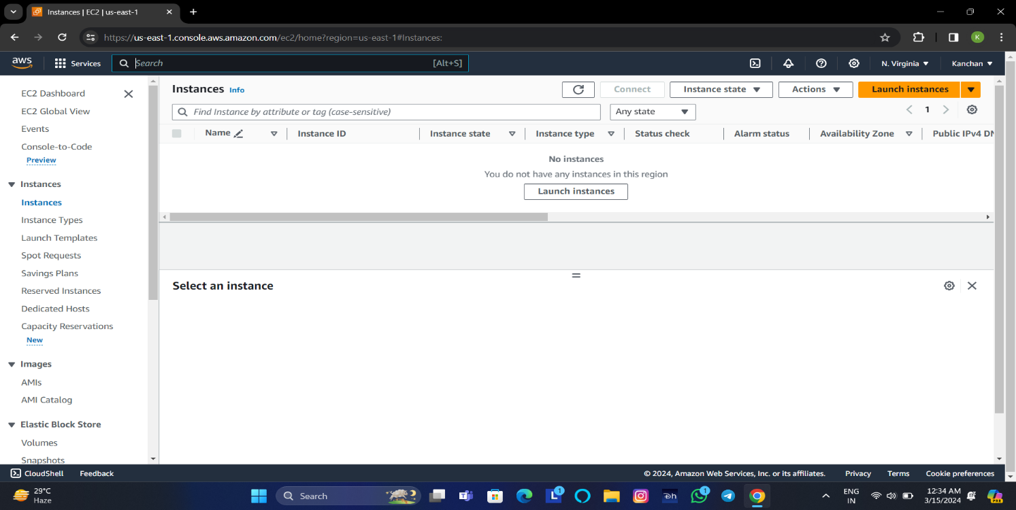

3. On the launch instance page, under **Name and tags**, for Name, enter

a descriptive name for your instance.

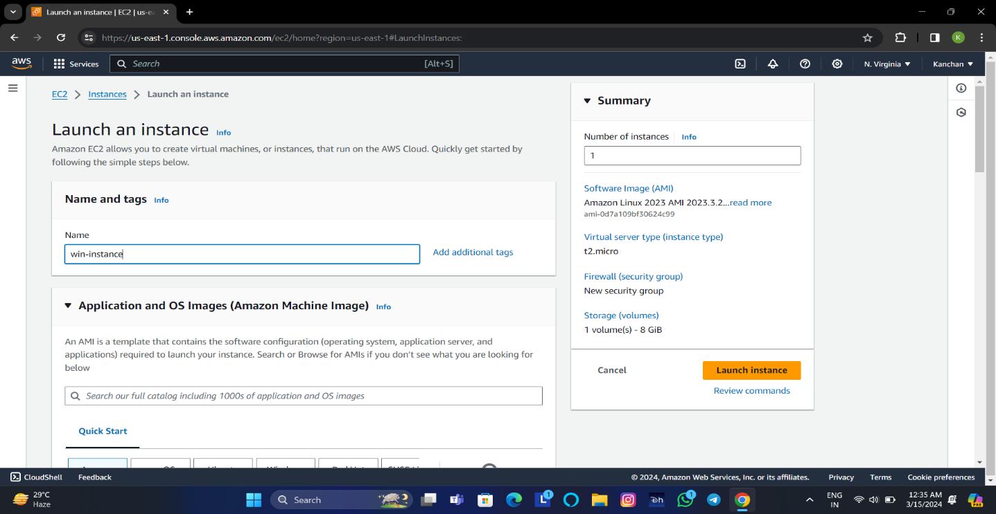

4. Under Application and OS Images (Amazon Machine Image) select

the **AMI** for Windows Server. 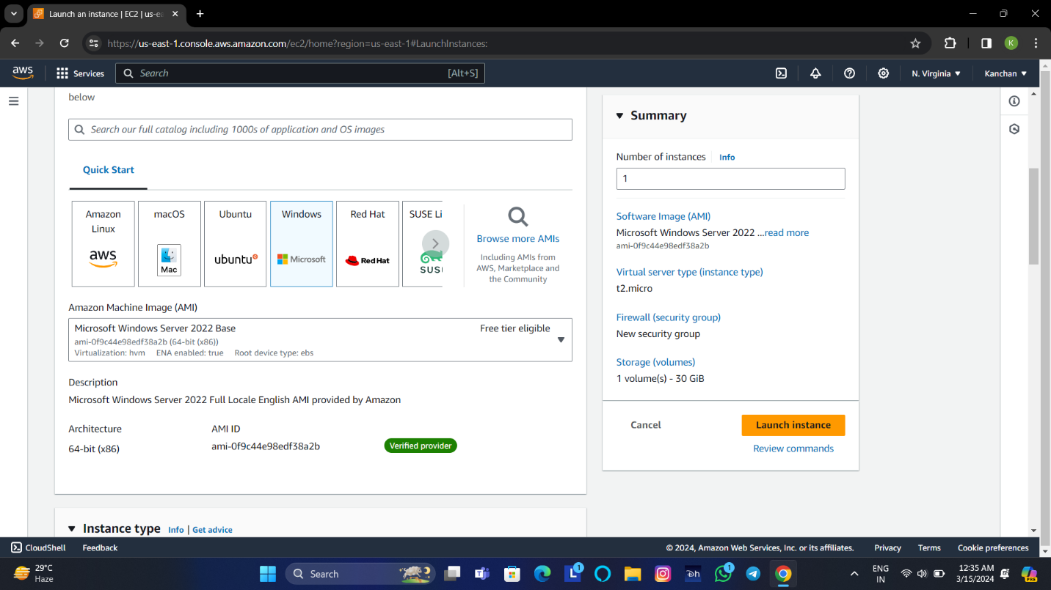

5. Under the instance type, from the instance type list select the

hardware configuration for instance. Choose **the t2.micro** instance

type.

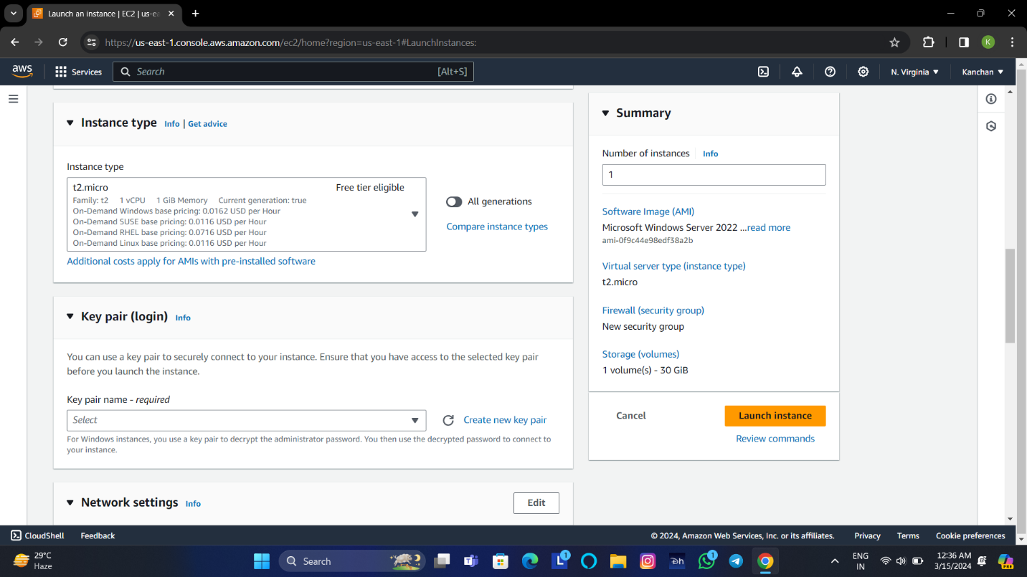

6. Under key pair, choose the key pair or create the key pair.

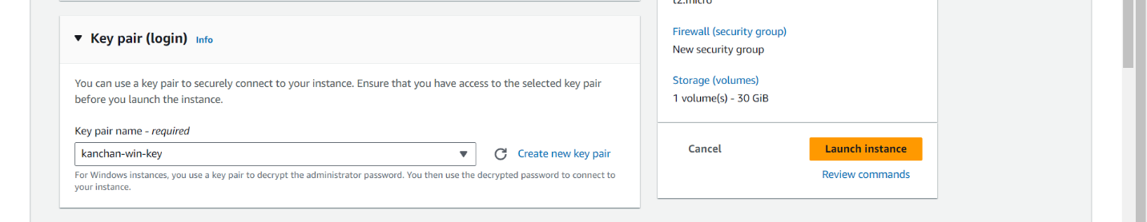

7. Under the configure storage, choose volume less than 30.

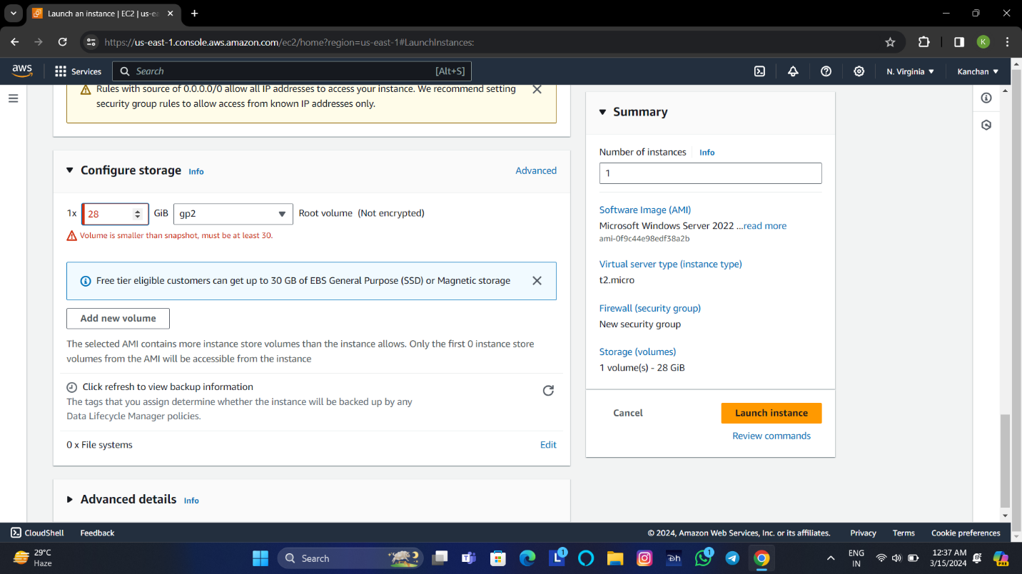

**2.Create an Amazon Linux instance**

* **Create a directory as normal user.**
* **Create a directory as root user.**

1.Go to the EC2 service in the AWS console.

2. From the EC2 console dashboard, in the Launch Instance box,

choose **Launch instance**.

3. On the launch instance page, under **Name and tags**, for Name,

enter a descriptive name for your instance. 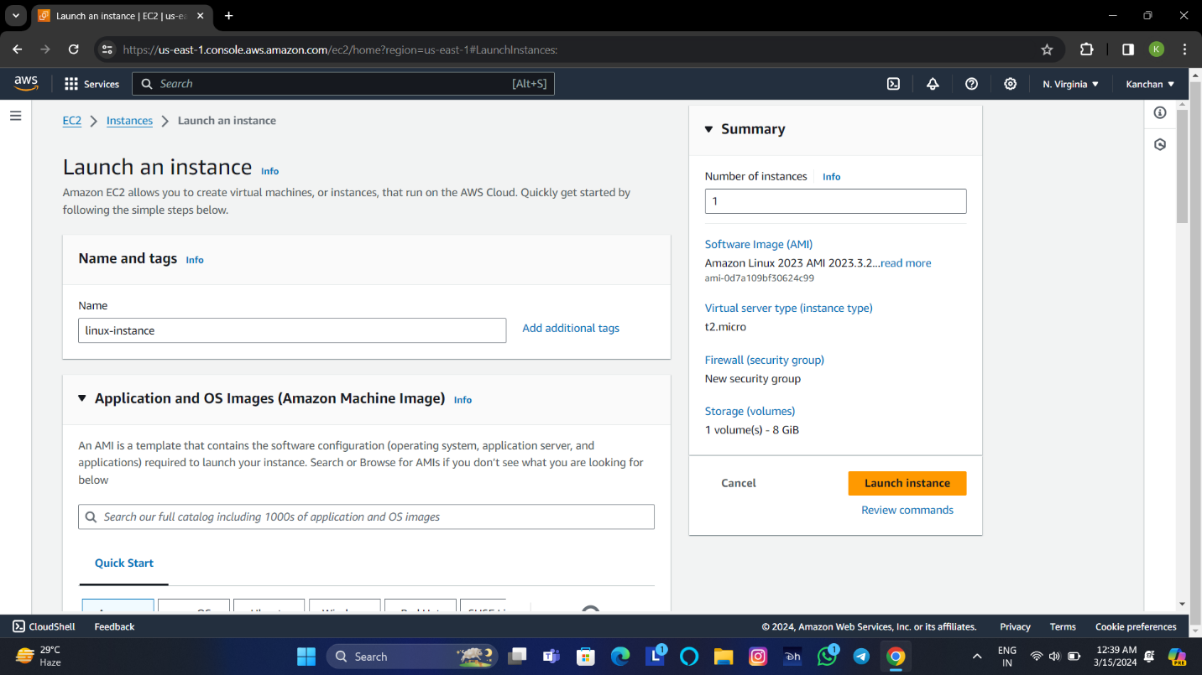

4. Under Application and OS Images (Amazon Machine Image)

select the **AMI** for **Linux Server**.

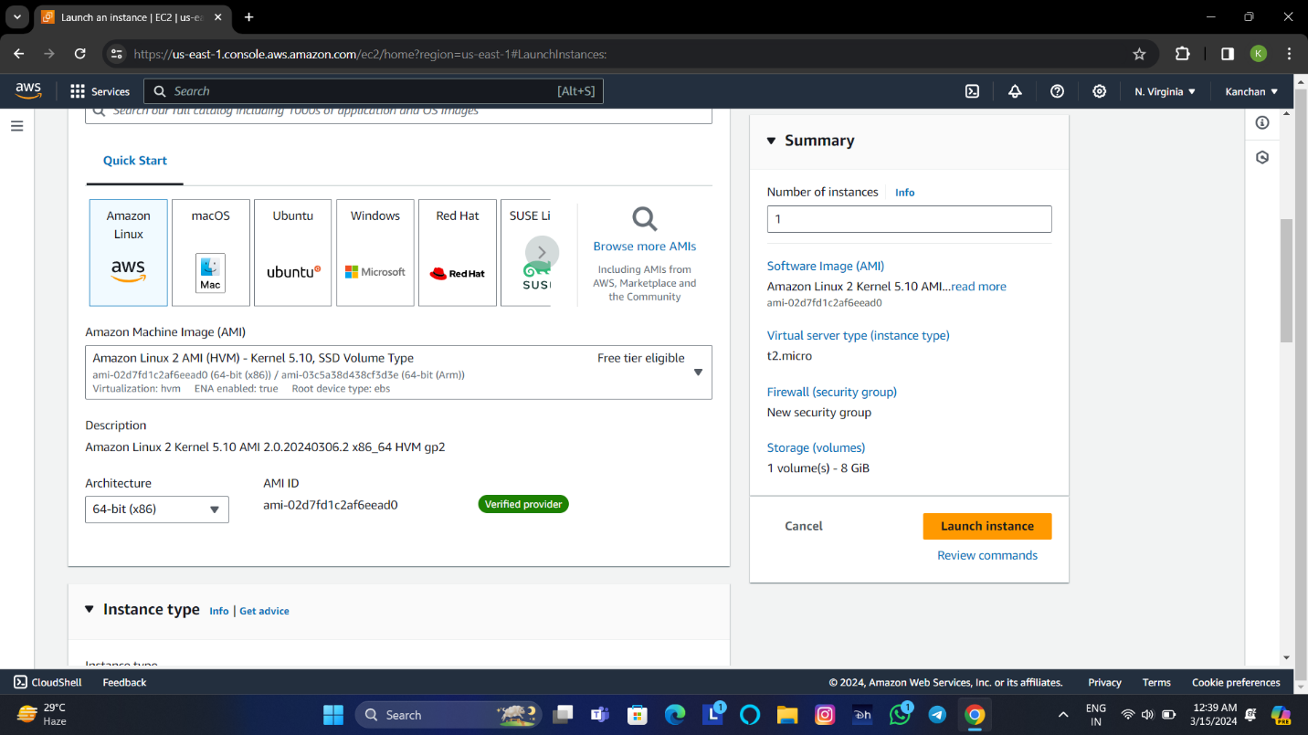

5. Under the instance type, from the instance type list select the

hardware configuration for instance. Choose the **t2.micro**

instance type.

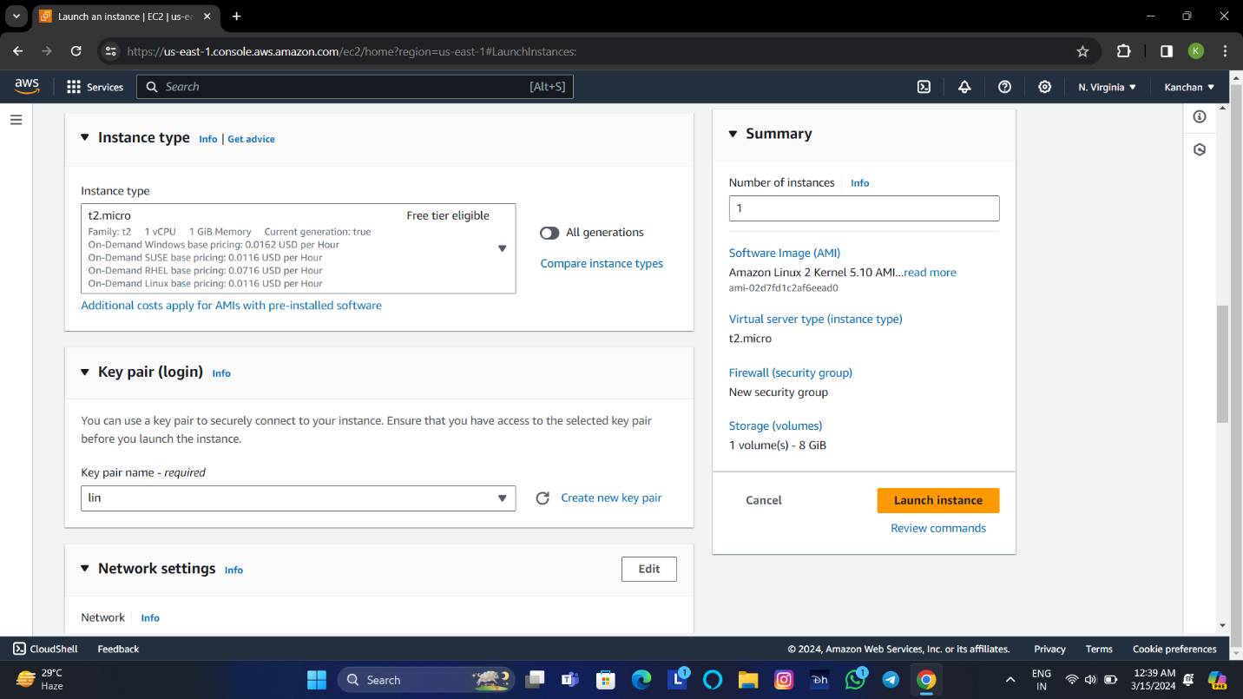

6. Under key pair, choose the key pair or create the key pair.



8. Choose **Launch Instance**.

9: Connect to the **instance**.

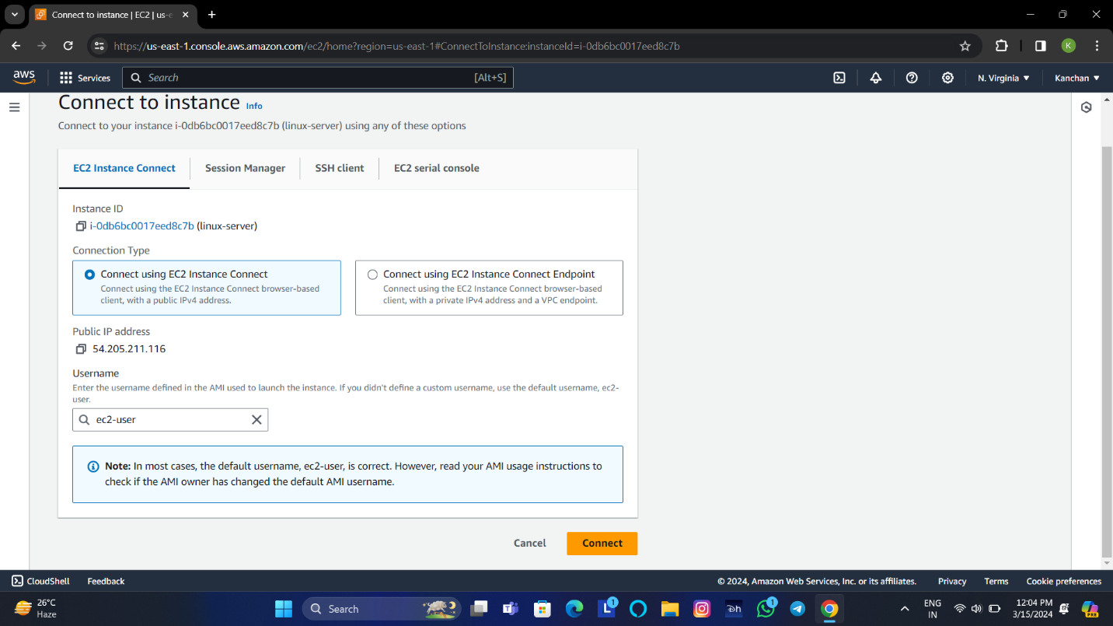

10. Click on **connect**.

* **Create directory as normal user.**
* Give command for make directory mkdir filename.

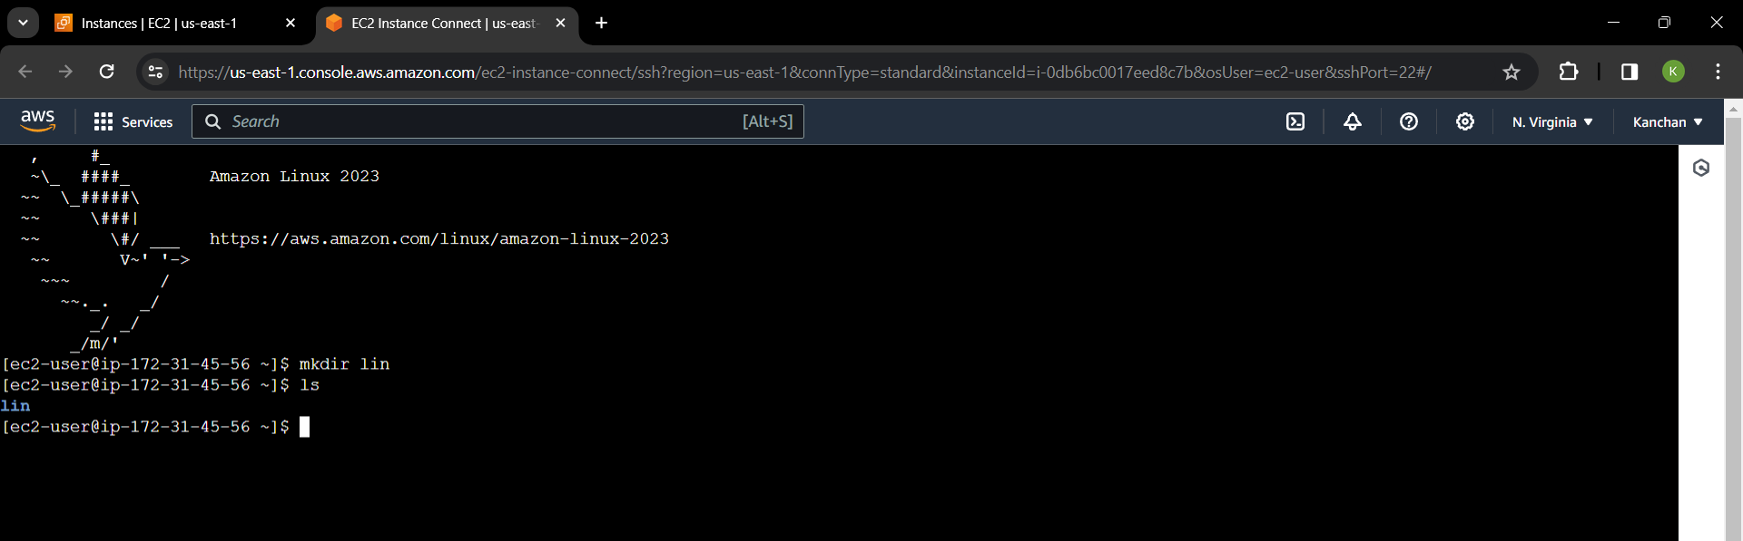

* **Create directory as root user.**
* Firstly, convert normal user to root user with the

Help of command **sudo su –**

* Give command for make directory mkdir filename.

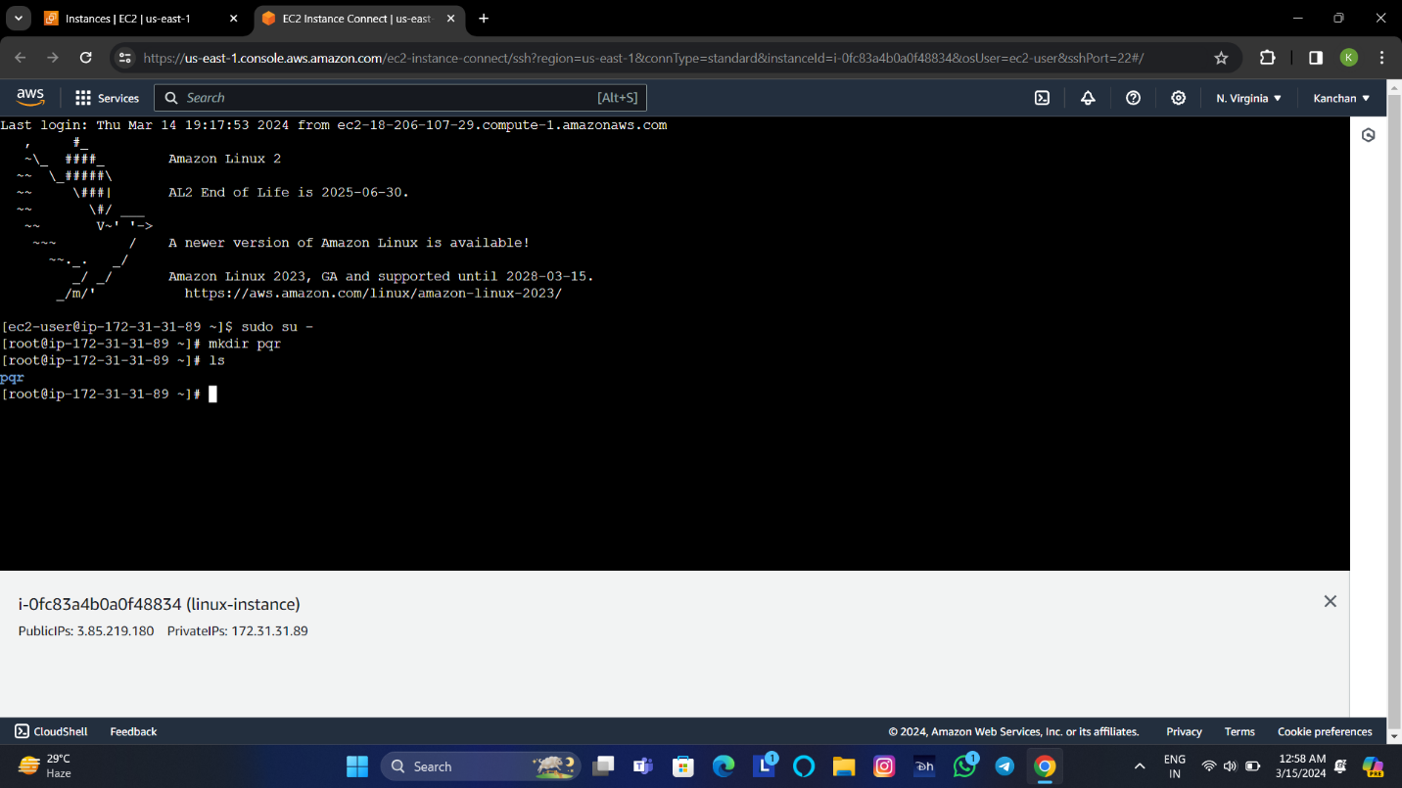

**3.Create one EC2 instance with two volumes.**

* **One volume with delete on termination enabled.**
* **One volume with delete on termination disabled.**

1. Open the amazon EC2 console

2.From the EC2 console dashboard,in the Launch instance box,

choose **Launch instance.**

3.On the Launch Instance page,under **Name and tags**,enter a

descriptive name for instance.

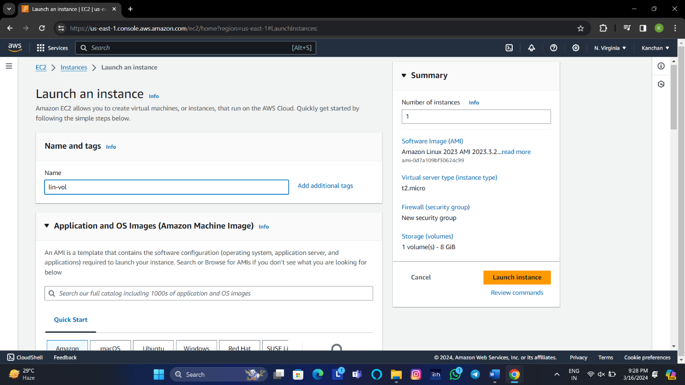

4. Under the Application and Os Images (Amazon Machi e Image),

choose quick start, and then chooose **Amazon Linux**.

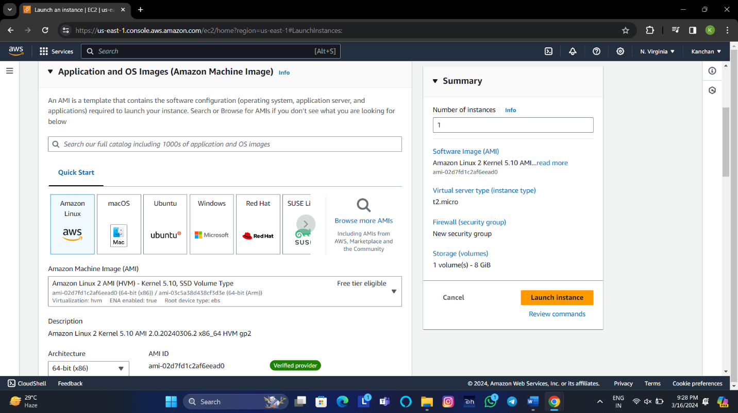

5. Under Instance type ,choose the **t2.micro** instance type.

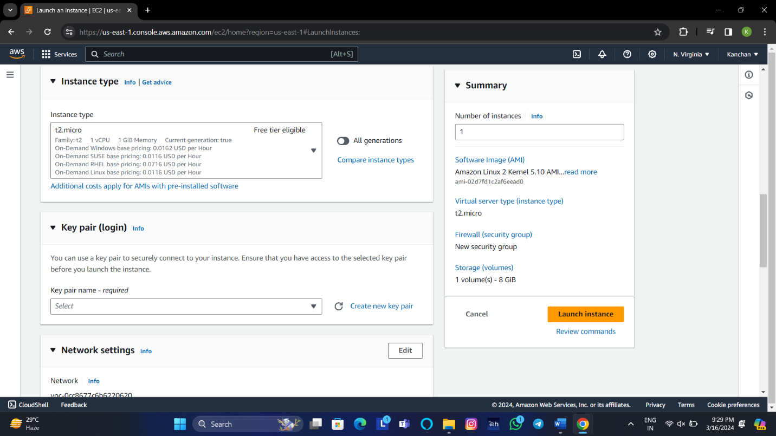

6. Under key pair, choose existing key pair or create a new one.

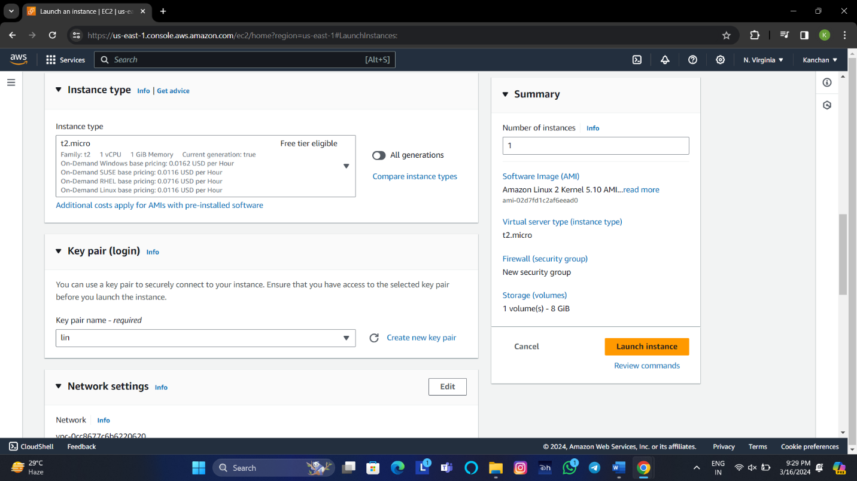

7. Under network security,edit the network security and

choose the **zone**.

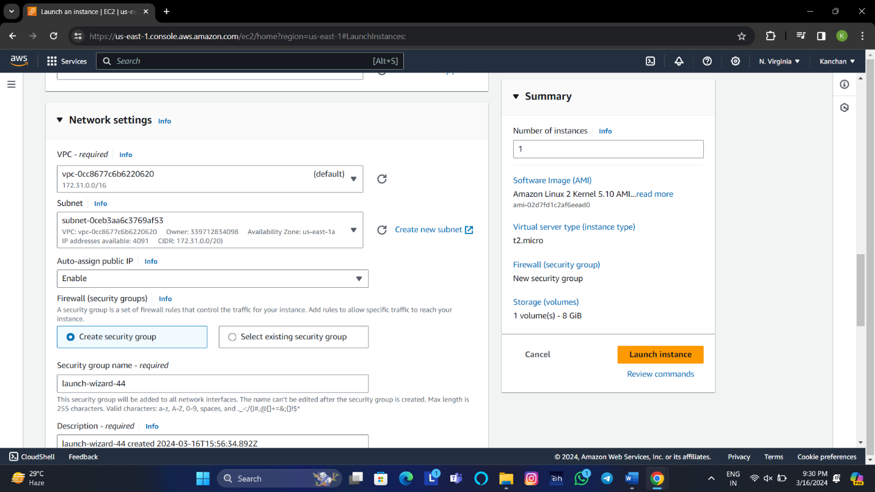

8.Under the configure storage, choose **add new volume**,provision it

specifying size.

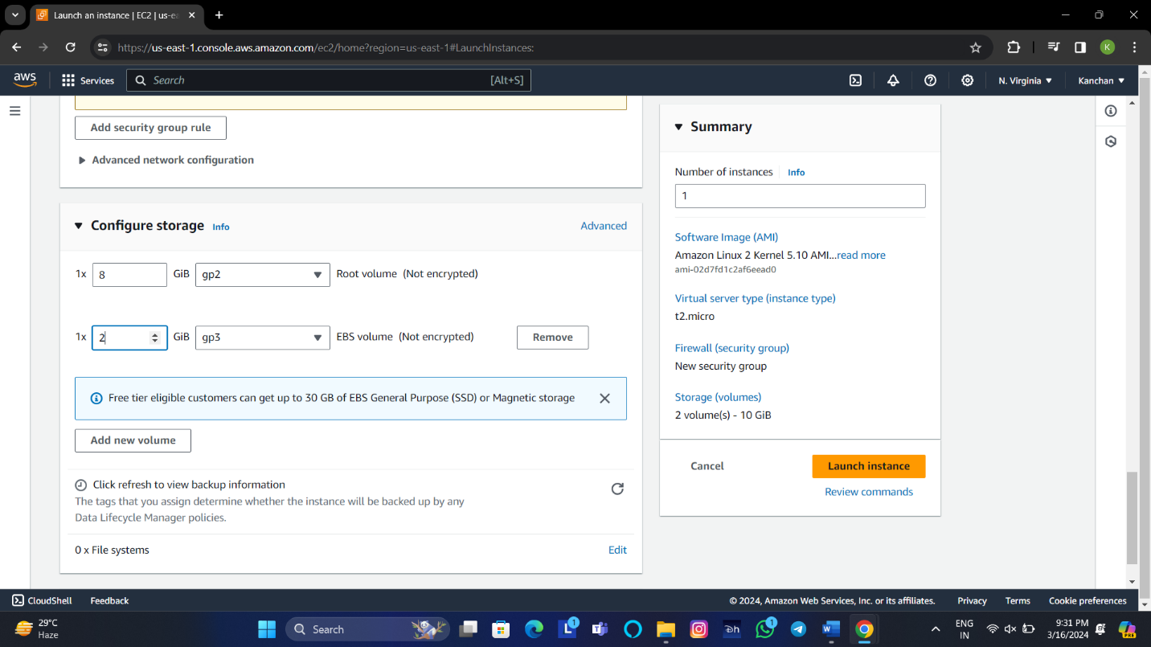

9.Choose **Launch Instance**.

10.Check **volume attachment status**.

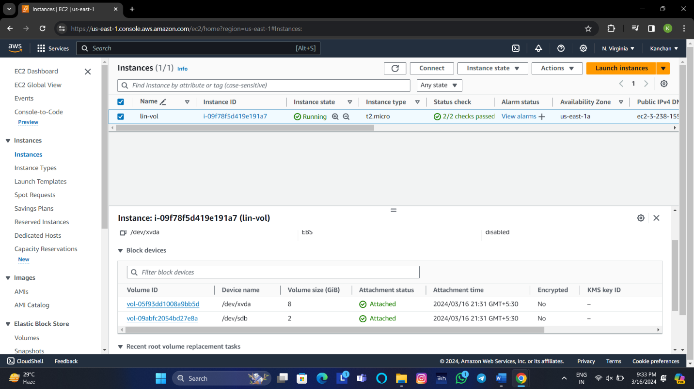

**4.Create a server with a custom AMI where the base server is having Windows OS and a website hosted on it.**

1. Go to the EC2 service in the **AWS console**.

2. From the EC2 console dashboard, in the Launch Instance box,

choose **Launch instance**.

3.Under **Name and tags**, for Name, enter a descriptive name for your

instance.

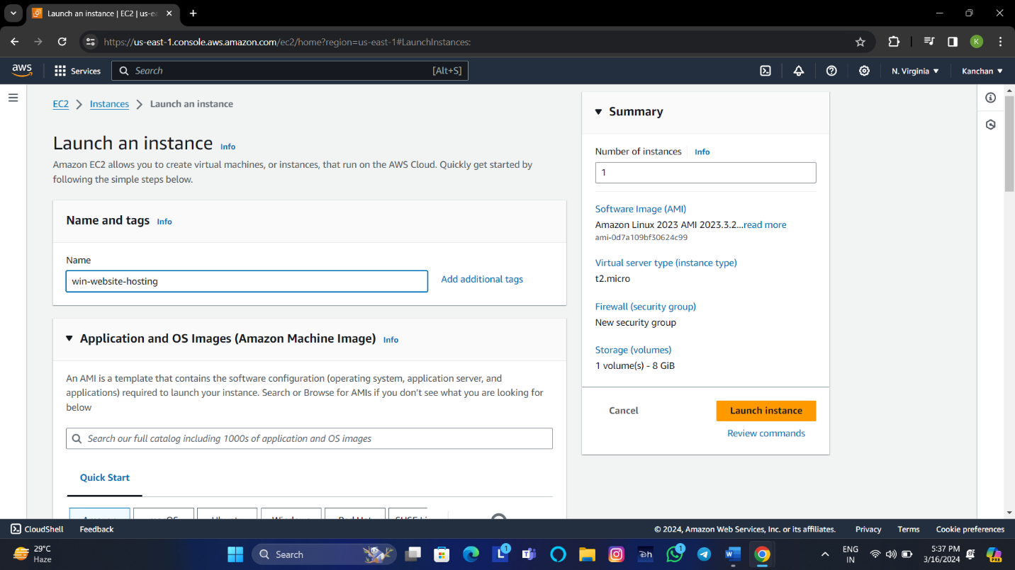

4. Under the Application and Os Images (Amazon Machi e Image),

choose quick start, and then chooose **Windows server.**

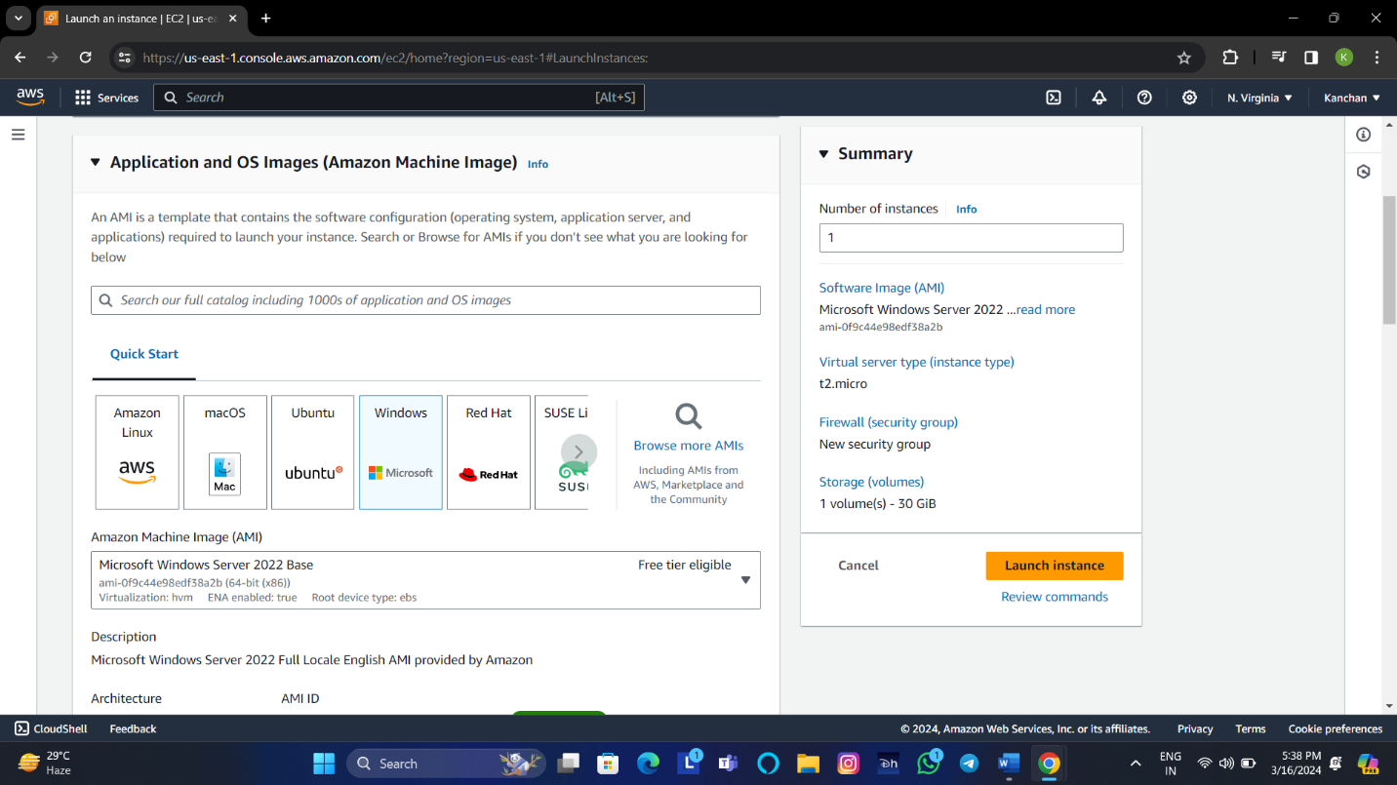

5. Under the network settings ,allow https and http ,click on Edit

then choose zone from the list of subnet.

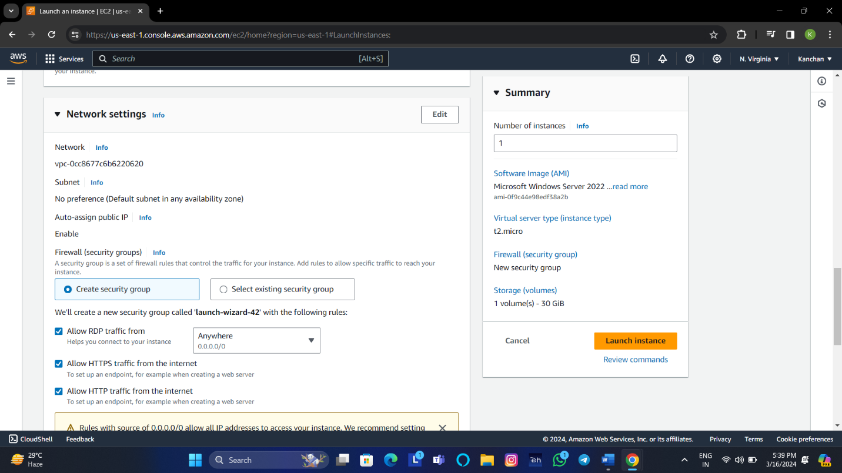

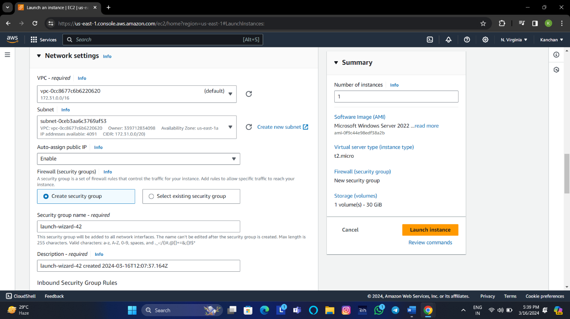

6.Choose **Launch Instance.**

7.Connect to **the instance**.

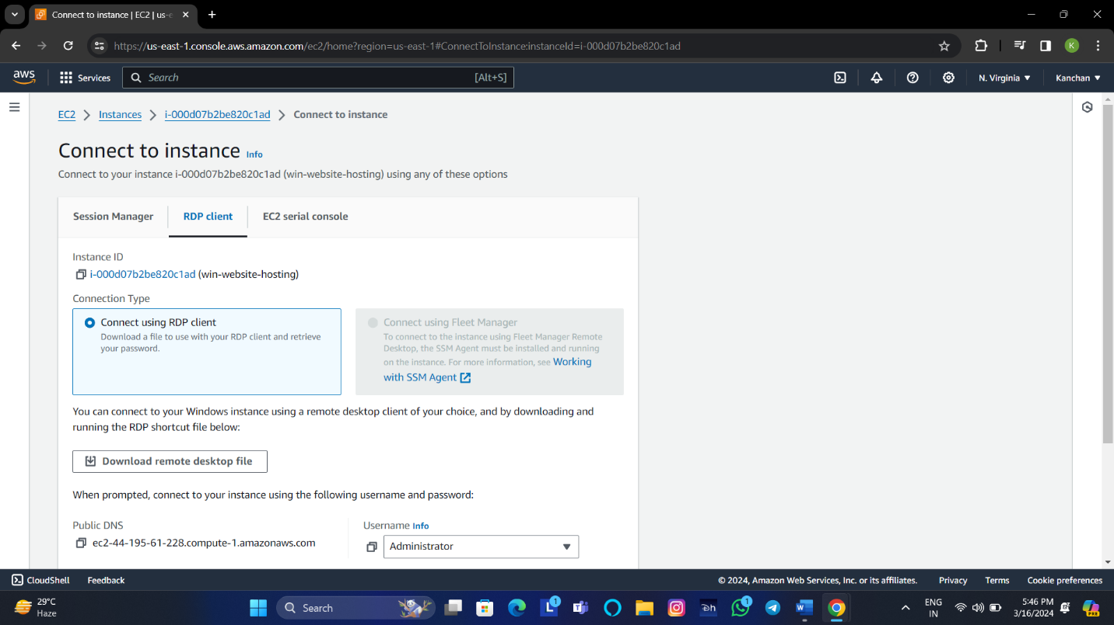

8.Choose **Get Password**, then Amazon EC2 instance upload private

key associated with the windows server.

9.Choose **Decrypt Password,** and then copy Password.

10.Choose Download Remote Desktop File, and then open the

file.

11.Paste the **password**.

12.Change the password with the help of cmd.

13.Go to the **server manager** and install the **IIS** (Internet

Information Services).

14.Go to **C drive** > **inetpub** > **wwwroot** > **upload webpages**.

**Create an AMI**

1.Select the instance from which to create the AMI then choose **Actions,Images and templates,Create image**2.

2.On the create image page

* Under the **image name** ,enter a unique name for the image.
* Under the image description,enter an optional description of the image.
* Click on the check box for **No reboot** is selected.

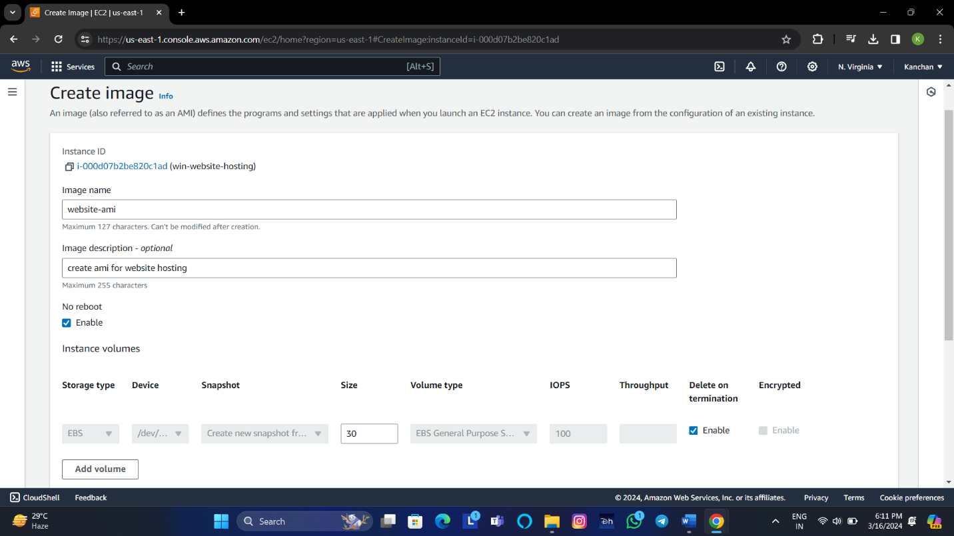

* We tag the AMI and the snapshots with same tags, or you can tag them with different tags, then choose **create image.**

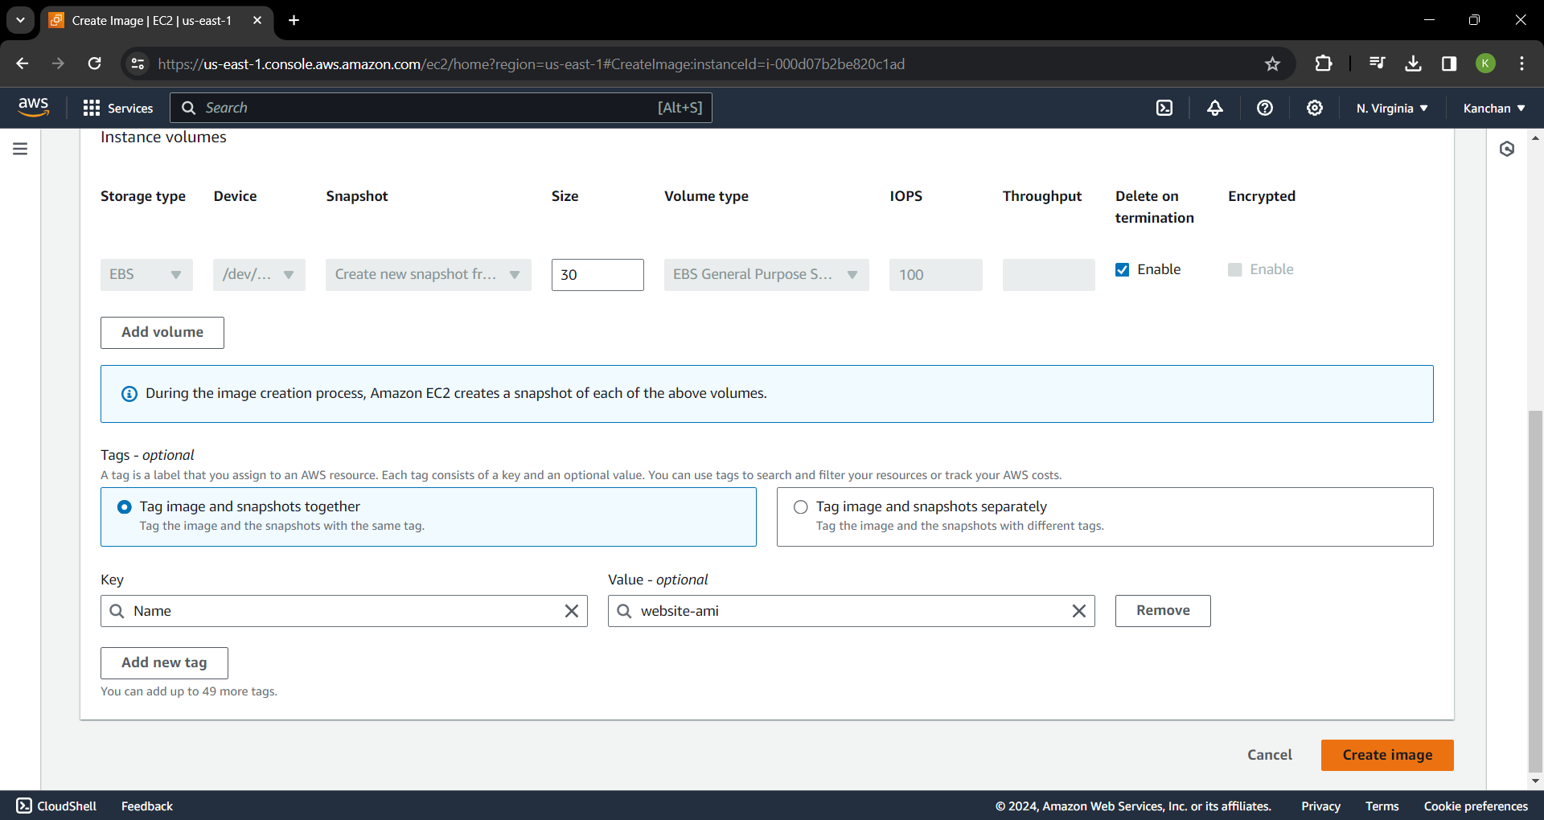

**Launch instance from an AMI**

1. From the Amazon EC2 console dashboard, choose **launch instance**.
2. On the launch instance page, under the **name and tags** enter the name.

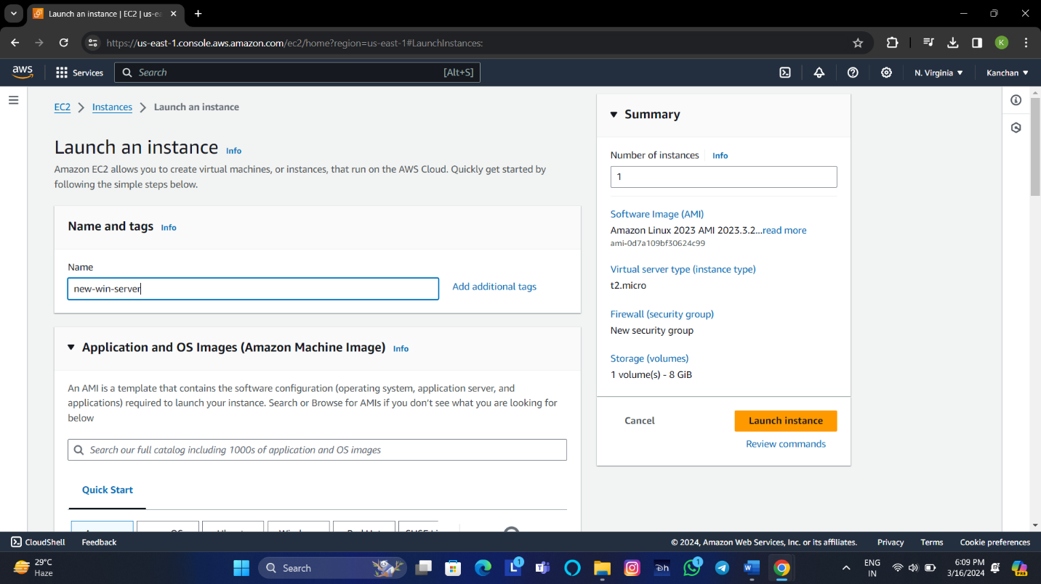

1. Under Application and OS Images (Amazon Machine Image), choose **My AIMs** then set filter to **owned by me**.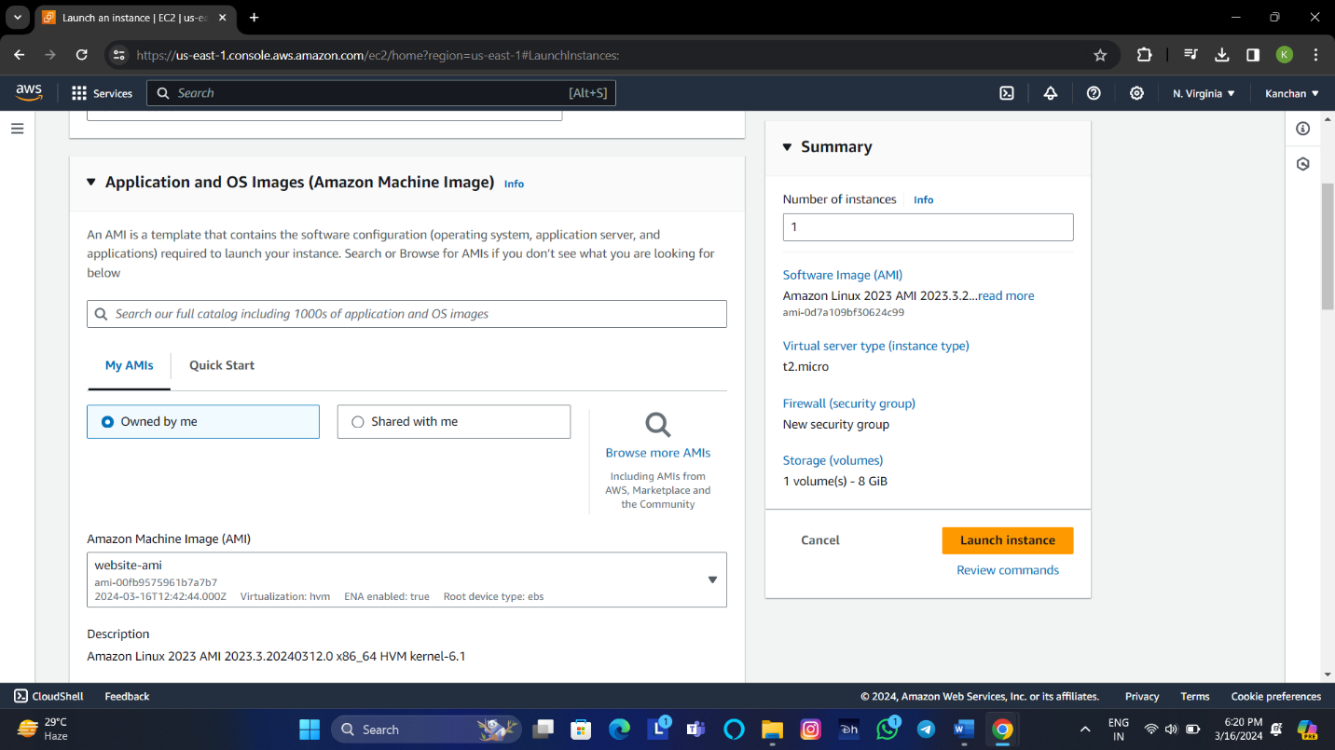

4.Under key pair, choose proceed without a key pair or existing key pair or create a new one.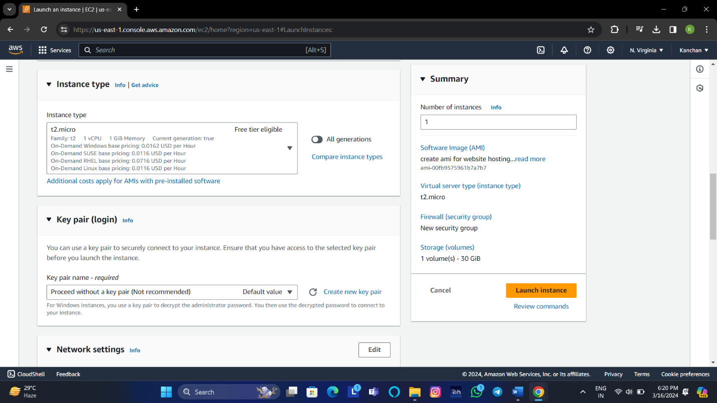

5.Under the network settings ,allow https and http ,click on

Edit then choose zone from the list of subnet.

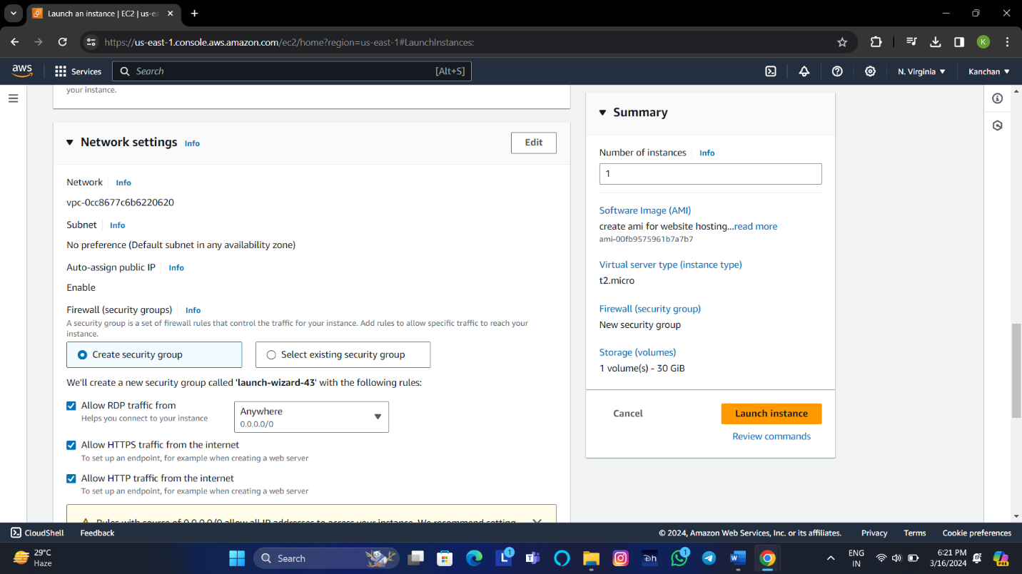

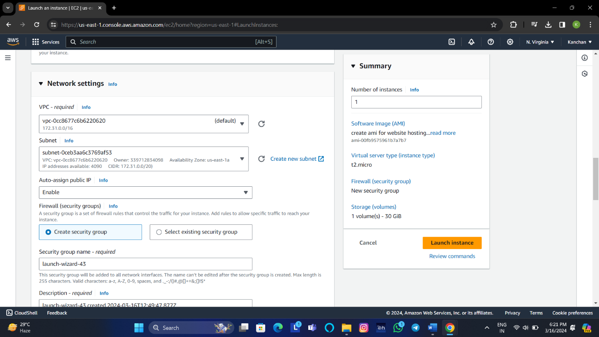

6.Choose **Launch Instance**.

7.Connect to **the Instance**.

**5.Create a server with a custom AMI where the base server is having Linux OS and a website hosted on it.**

1: Go to the EC2 service in the **AWS console**.

2: From the EC2 console dashboard, in the Launch Instance box,

choose **Launch instance**.

3: Under **Name and tags**, for Name, enter a descriptive name for you

your instance and select the **AMI for Linux Server**.

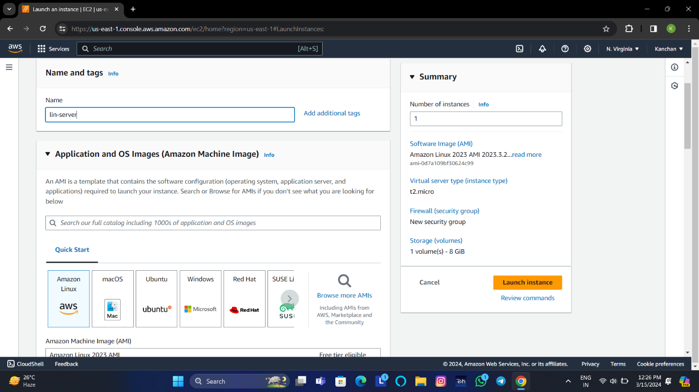

4: Under the network settings ,click on edit ,choose subnet from the

list of subnet allow https and http.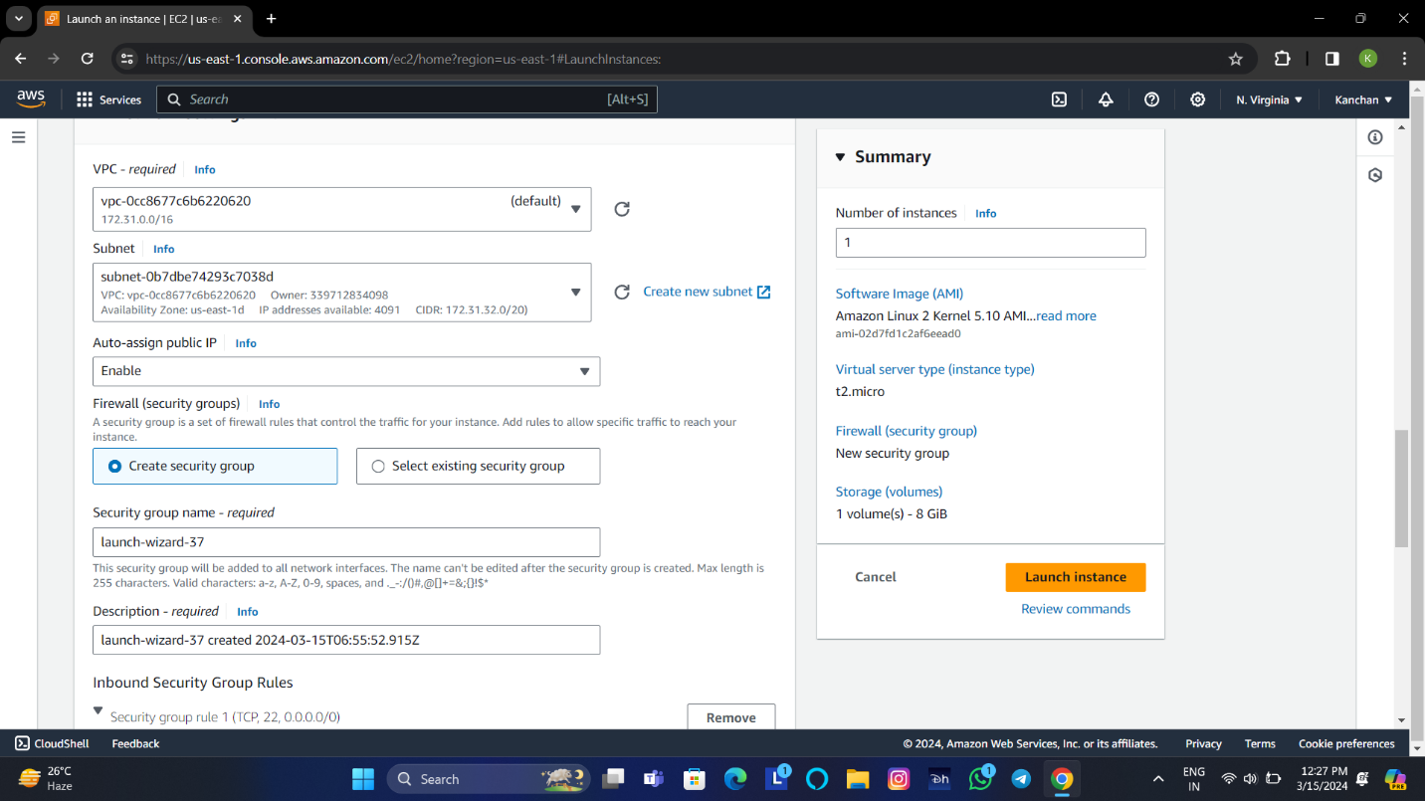

5: Connect to the **instance**.

* Firstly convert normal user to root user with the help of comman

**sudo su –**

* Update with the help of command **yum update**.
* Install httpd with the help of command **yum install httpd**.

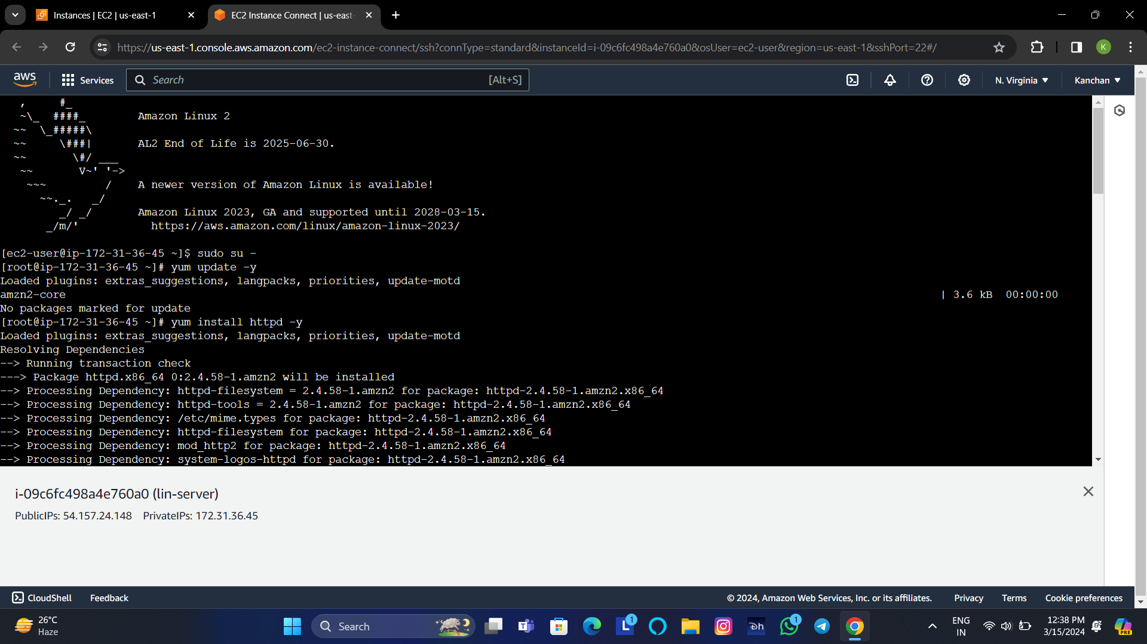

* Give command for start httpd **systemctl start httpd** and **chkconfig httpd on**
* Choose template from the browser and paste the **link address** in the server with the command **wget (address).**

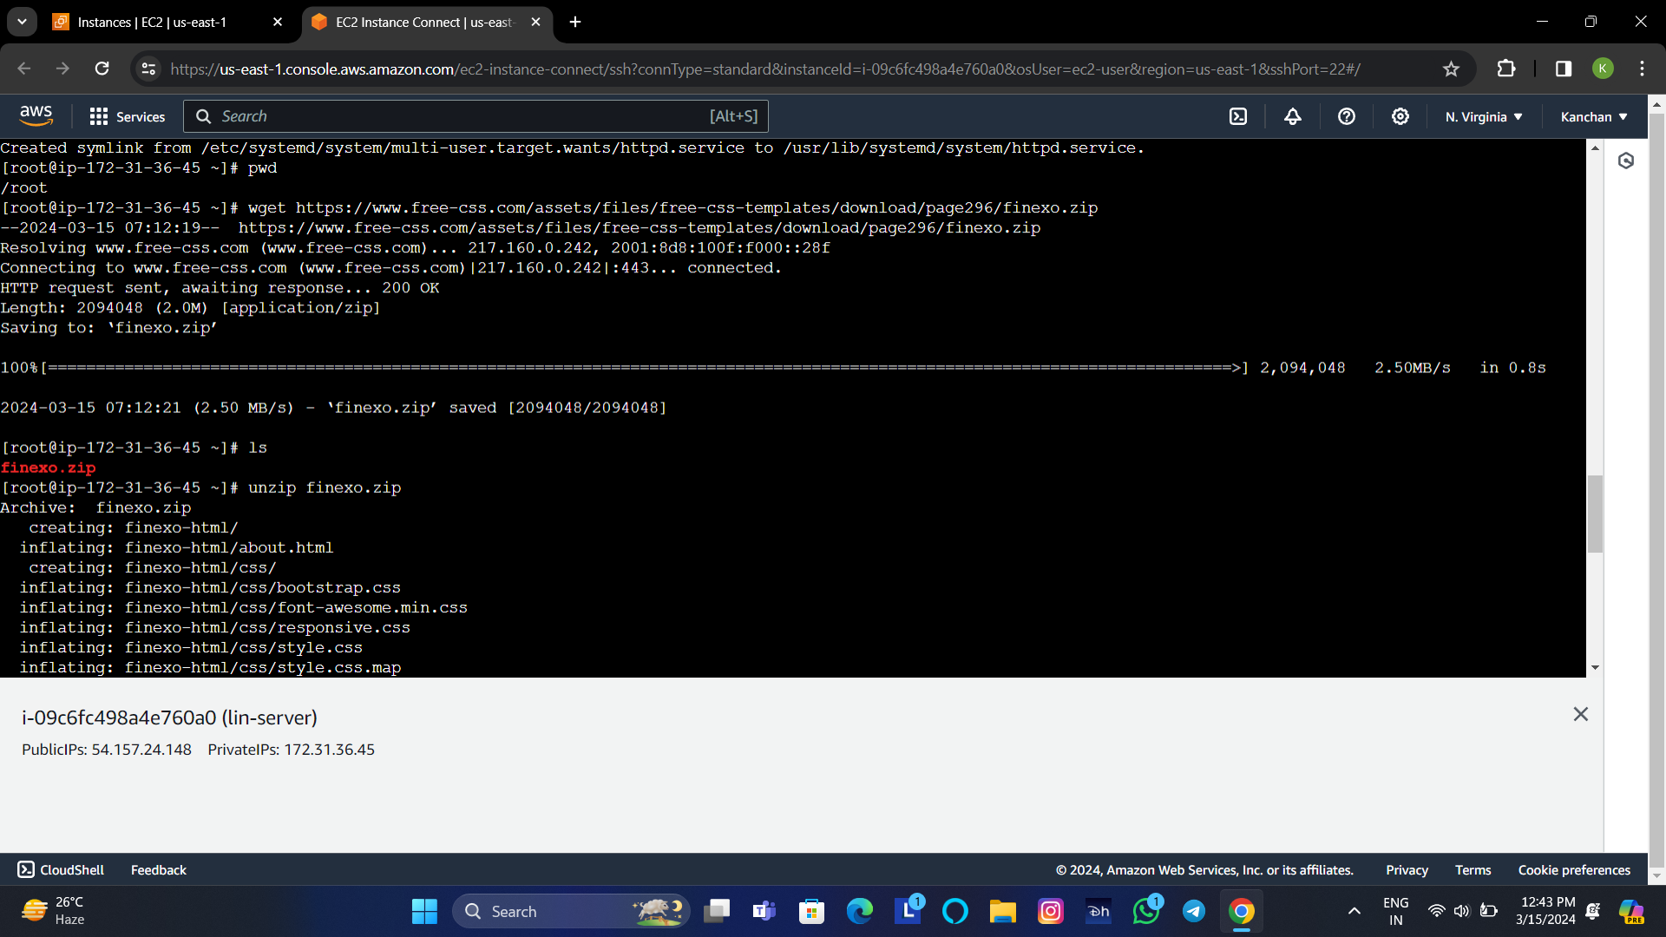

* **Unzip file** from zip file.



* Change directory with the commad **cd filename**.

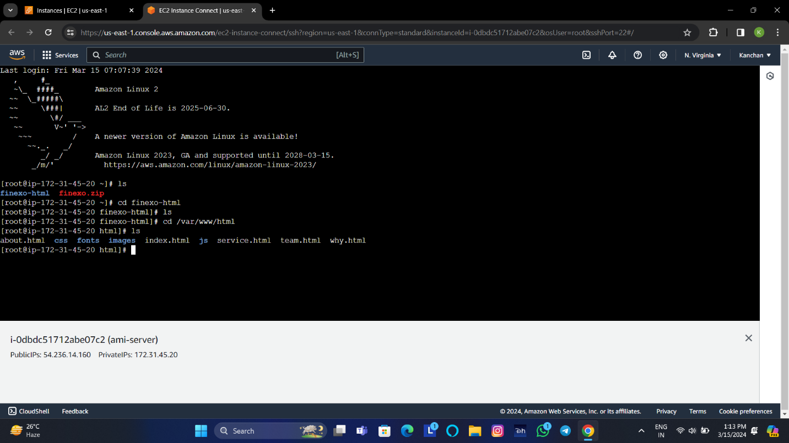

* move the file from **source to destination**.

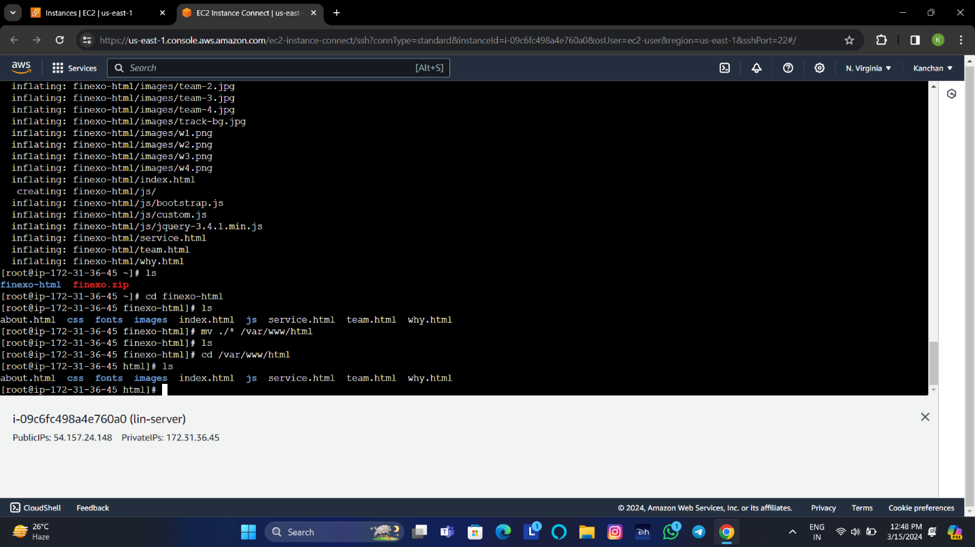

**To create an AMI**

1.Select the instance from which to create the AMI then choose

**Actions,Images and templates,Create image.**

2.On the create image page

* Under the image name ,enter a **unique name** for the image.
* Under the image description,enter an optional description of the image.
* Click on the check box for **No reboot** is selected.

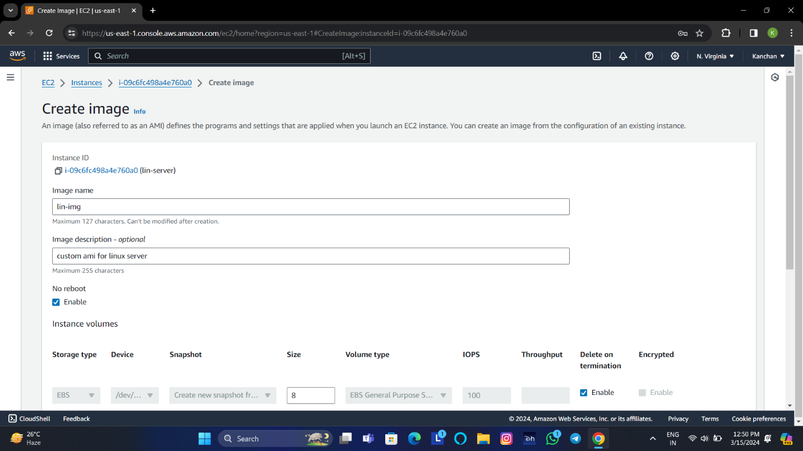

* We tag the AMI and the snapshots with **same tags**, or you can tag them with **different tags**.
* Choose **create image.**

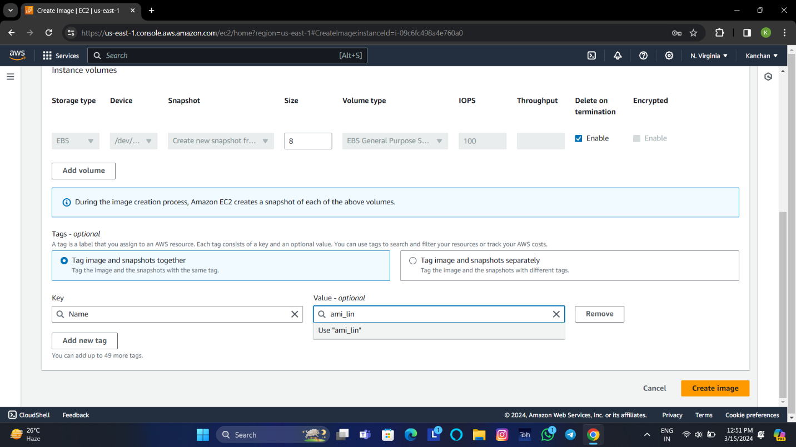

**Launch instance from an AMI**

1.From the Amazon EC2 console dashboard, choose **launch instance**.

2.On the launch instance page, under the **name and tags** enter the

name.

3.Under Application and OS Images (Amazon Machine Image), choose

**My AIMs** then set the filter to owned by me.

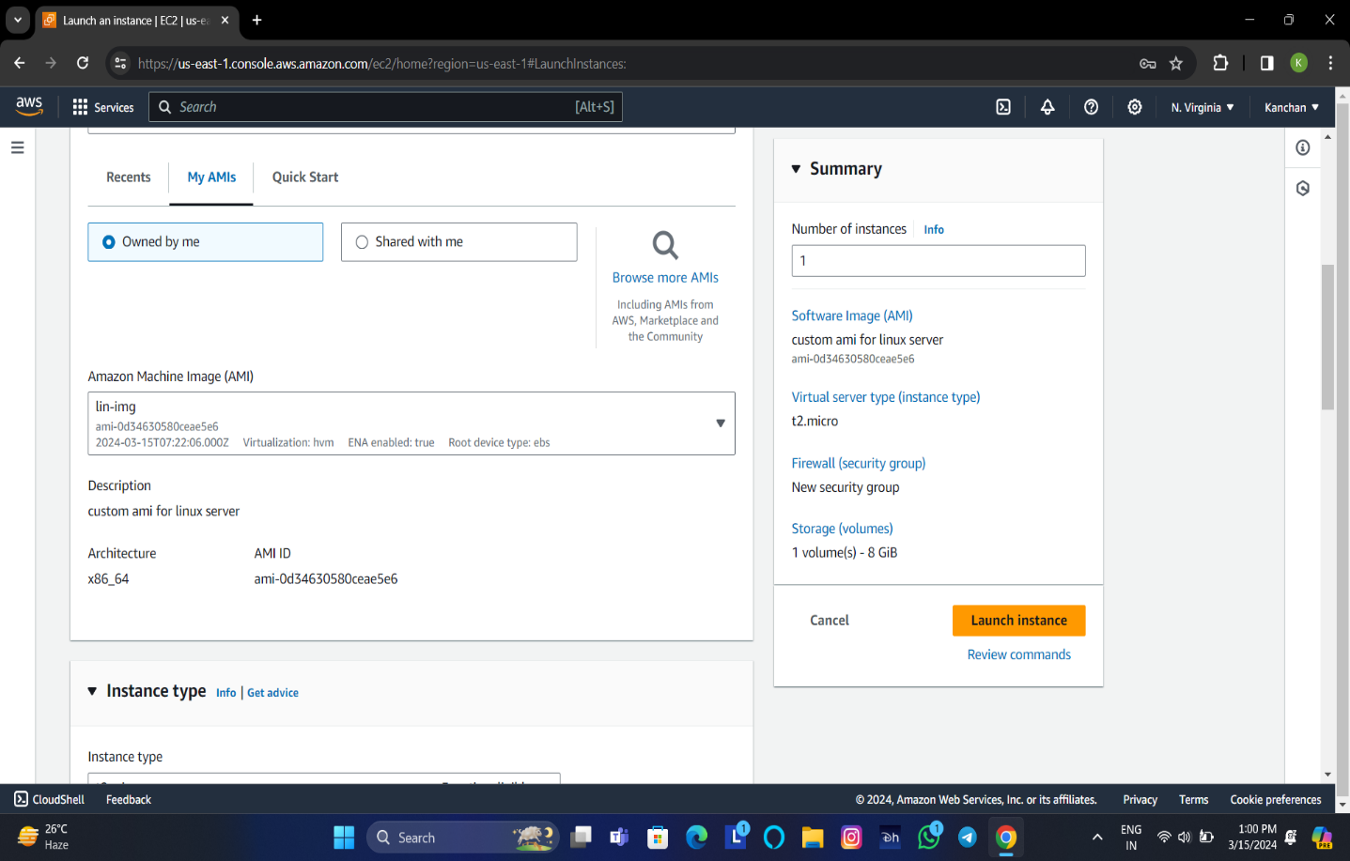

4.Under key pair, choose proceed without a key pair or existing key pair

or create a new one.

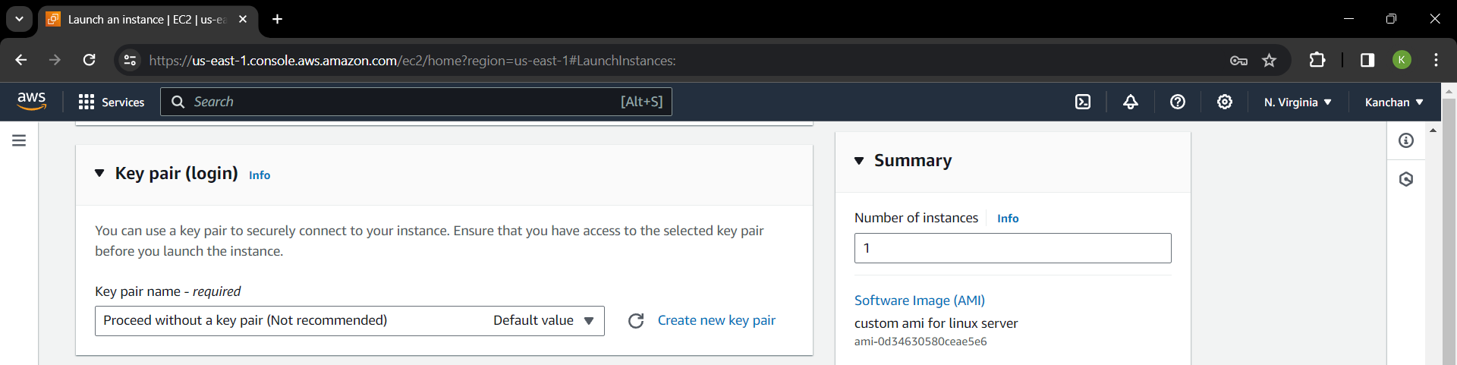

5.Under network settings, create security group.

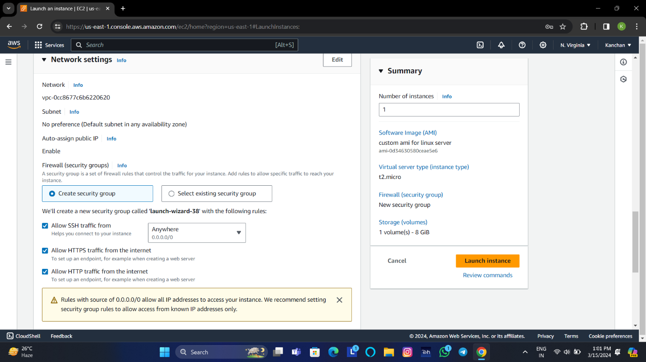

6.Choose **Launch Instance**.

**6.Add an extra volume to the Linux instance**

1. Open the **Amazon EC2 console**.

2.From the EC2 console dashboard,in the Launch instance box,

choose **Launch instance.**

3.Under **Name and tags**,enter a descriptive name for instance.

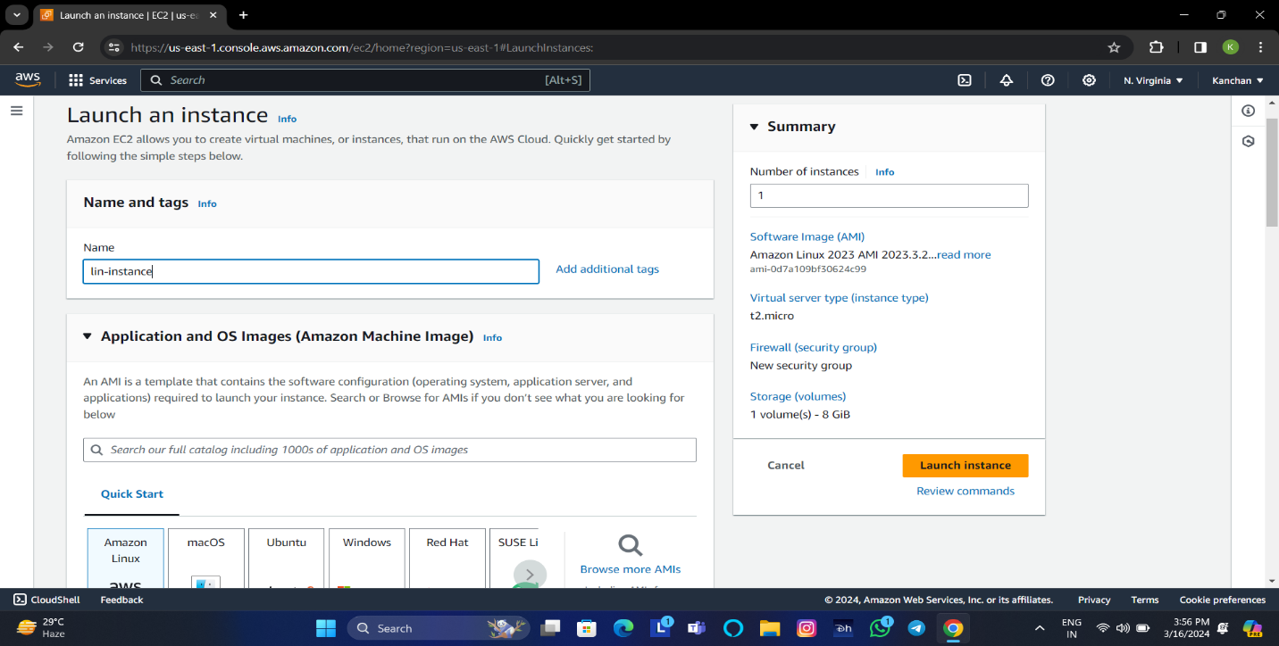

4. Under the Application and Os Images (Amazon Machine Image),

choose quick start, and then chooose **Amazon Linux.**

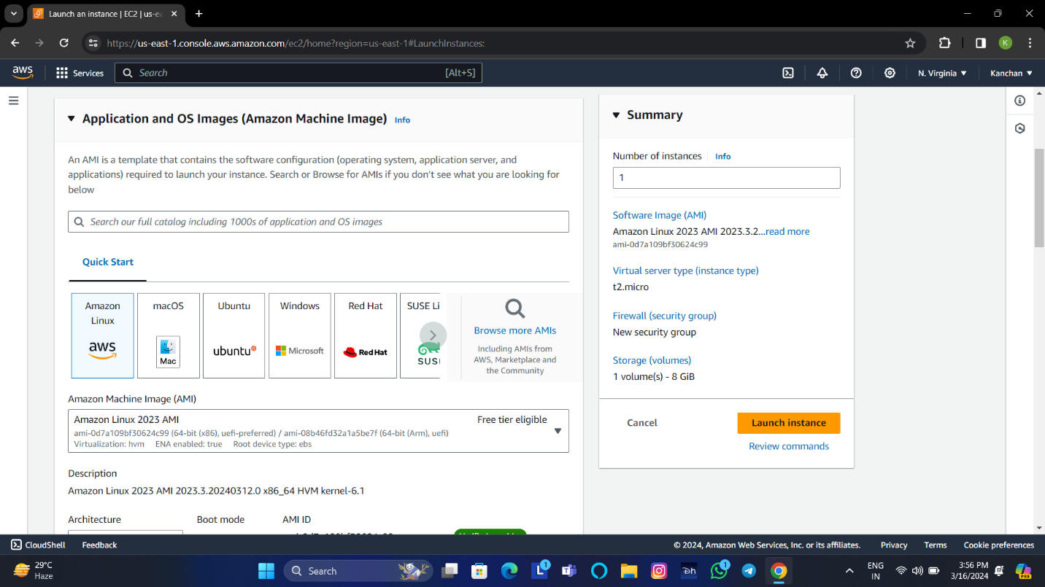

5. Under Instance type ,choose the **t2.micro** instance type 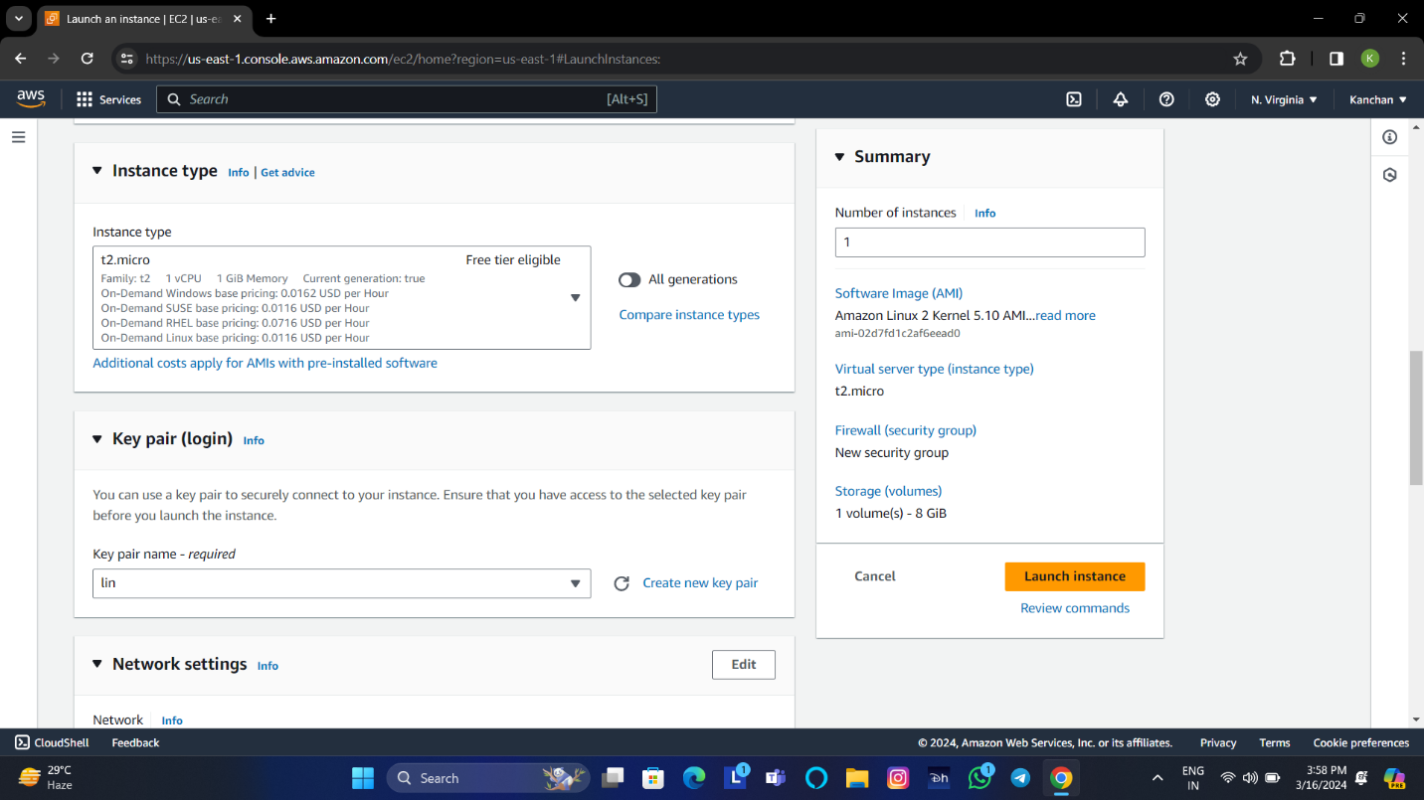

6.Under key pair, choose existing key pair or create a new one.



7. Under network security,edit the network security and choose the zone.

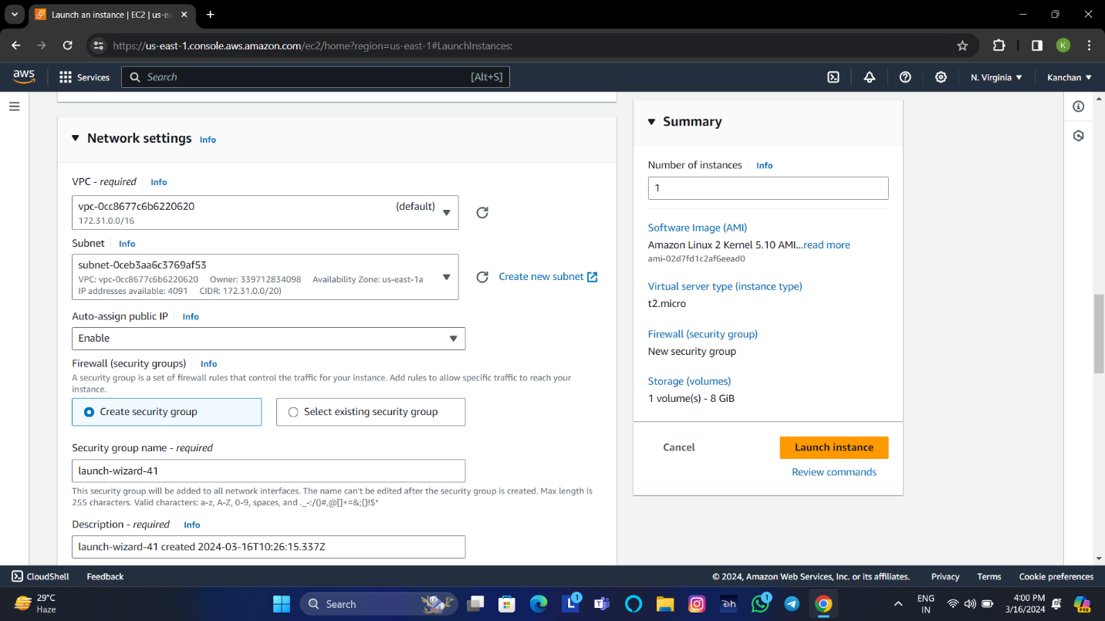

8. Choose the **Launch Instance**.

**To create a volume**

1.Open Amazon EC2 console.

2.In the Ec2 dashboard,select the volume under Elastic Block Store and click on create volume.

3.On the create volume page,choose among the available types and provision it by specifying size also provision the availability zone(**Both** **EC2 instance and volume should be in the same zone**), Tags(optional) and click to create volume option.

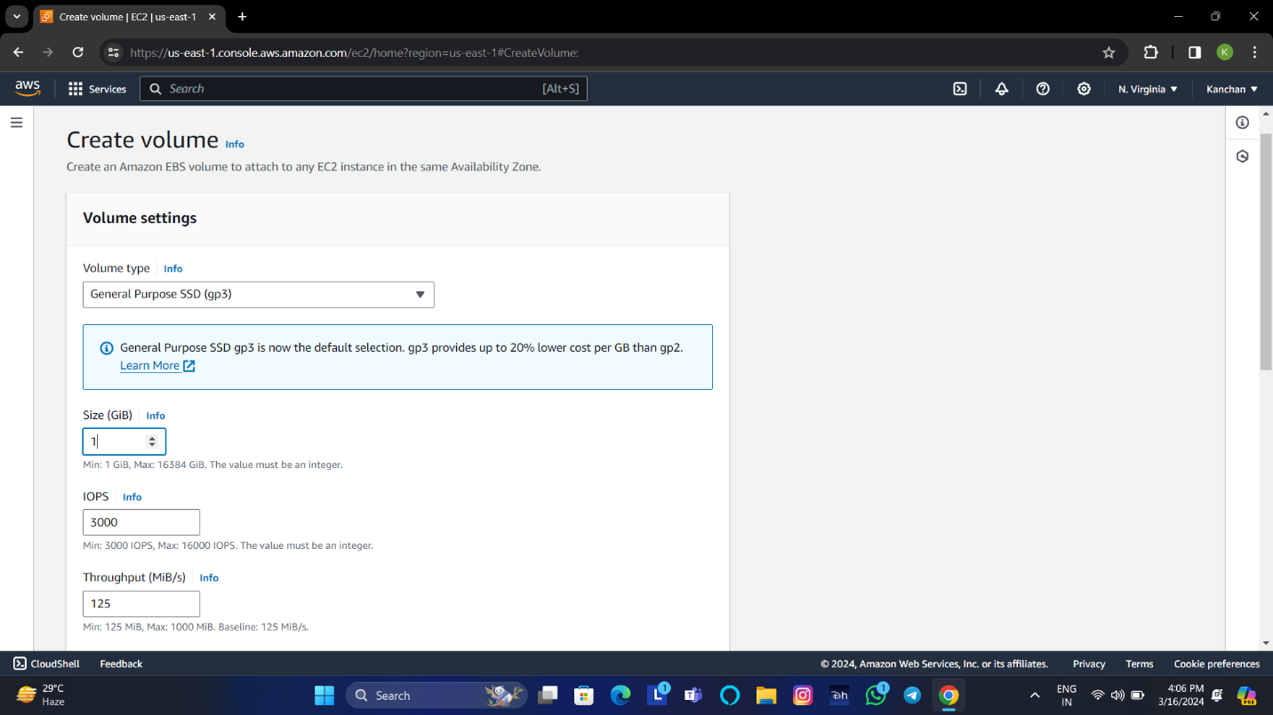

4.Check the volume status is available before using it.

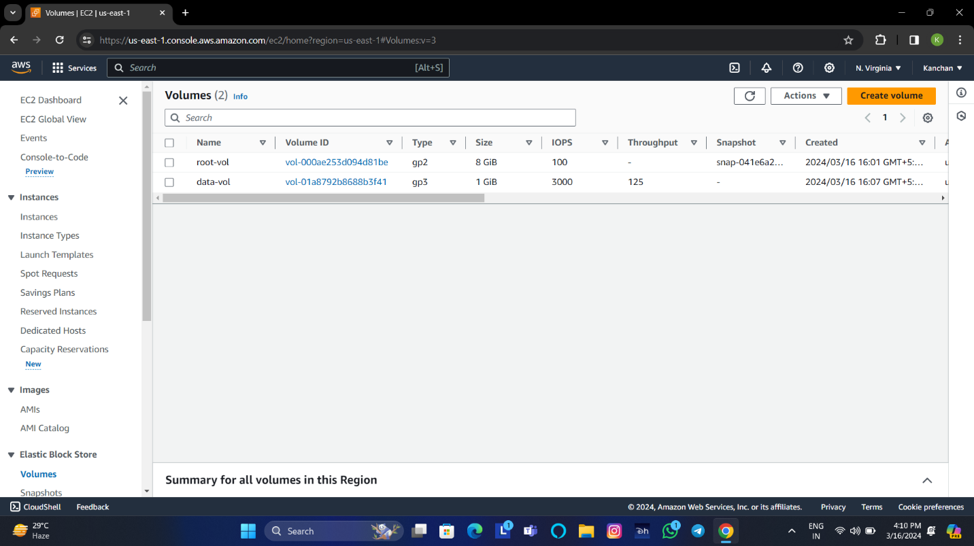

5.Attach the new EBS Volume to the EC2 instance,Selected created volume,Select **Actions**,click to **Attach volume**.

6.Select the instance from the list of options.Amazon EBS volume and the Amazon EC2 instance are in the same availability zone

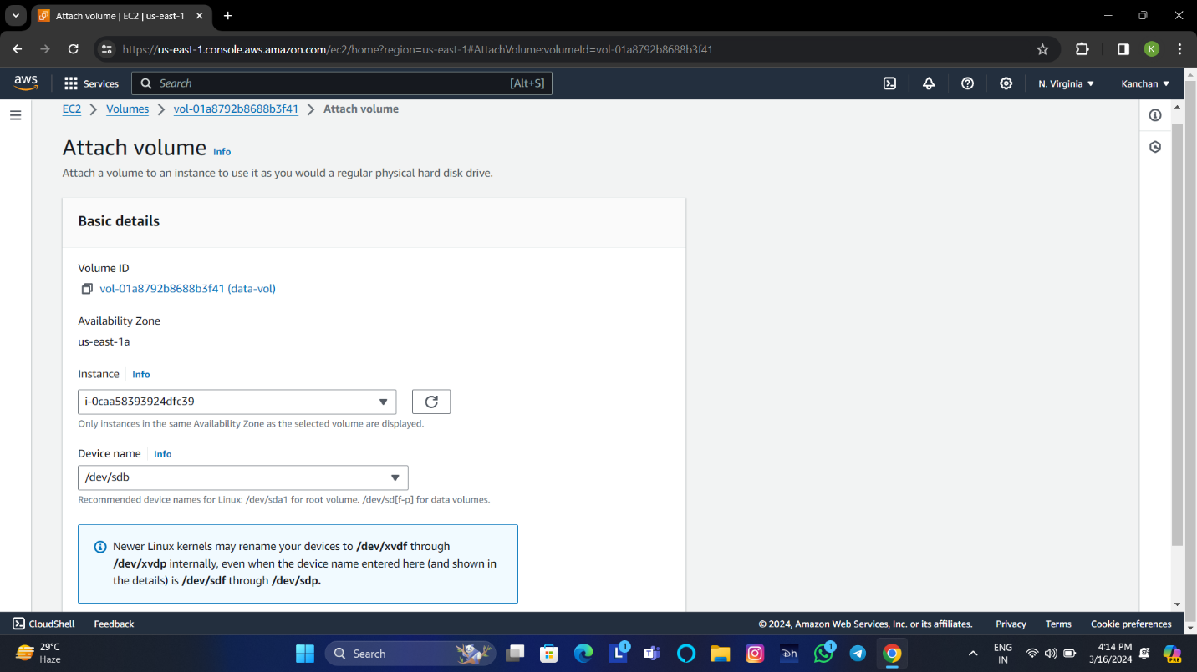

7.Choose **attach button**.

8.After attaching the volume,you will be able to see identical block devices for an EC2 instance.

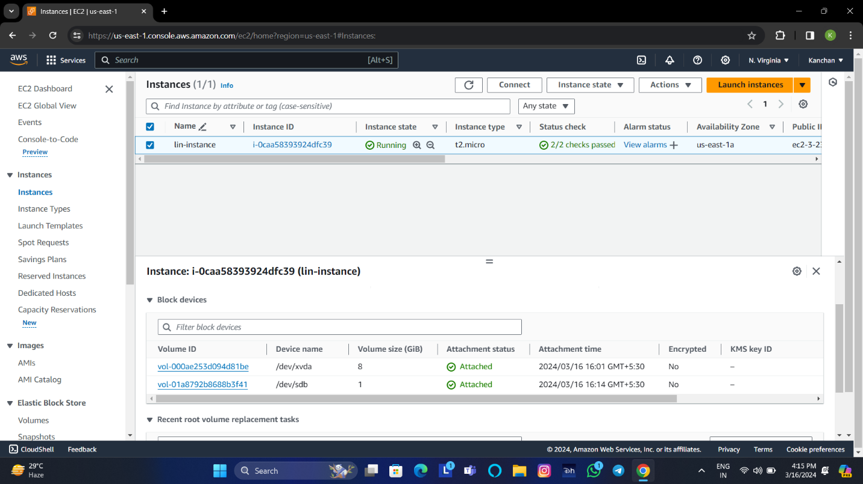

**7.Replace root volume of a server with the volume created from snapshot of other server.**

1. Create a **windows base server**.
2. Create **image from base server**.
3. **Terminate** the base server and **deregister** the image.
4. On the Elastic Block Store, **choose Snapshots**.
5. Go to Actions, then choose **create volume from snapshot**.
6. On the Volume page, under the volume settings create the new volume in the same availability zone as instance.

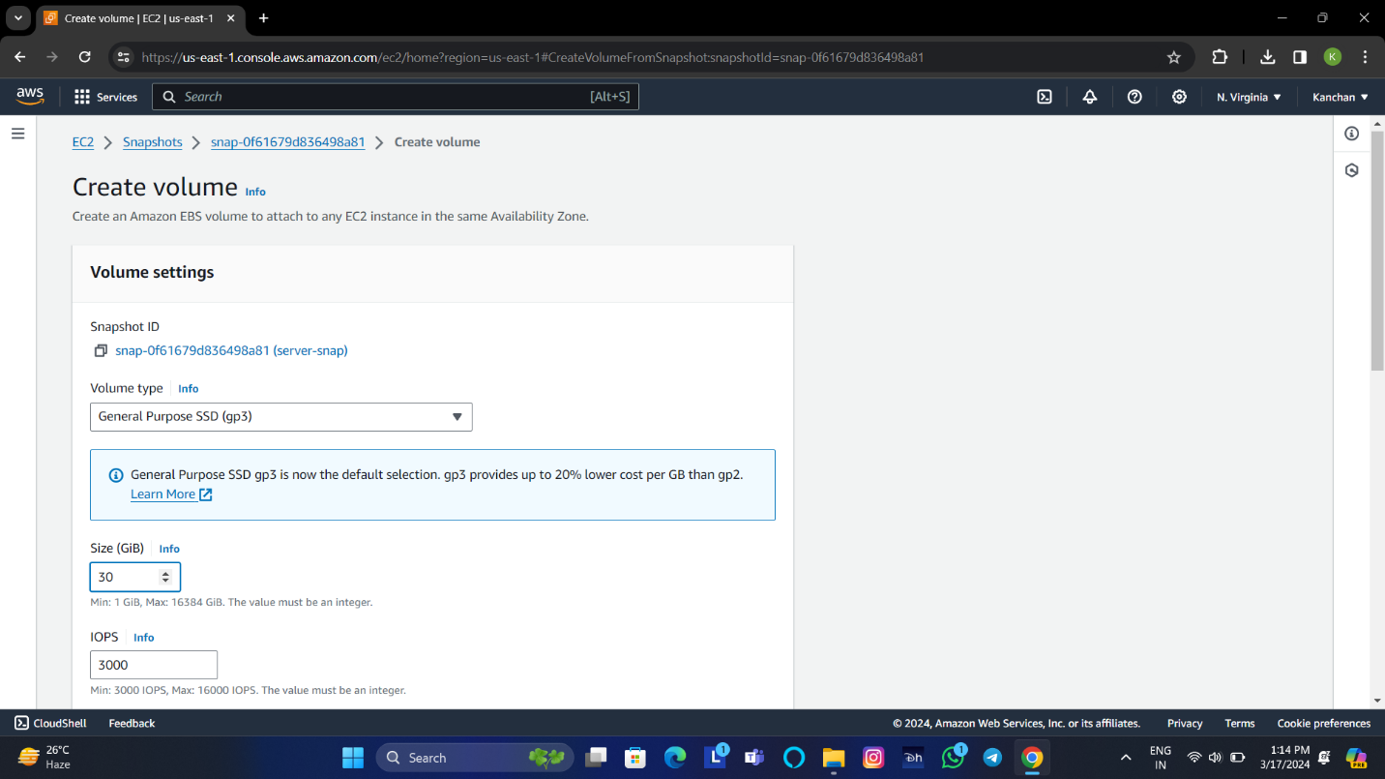

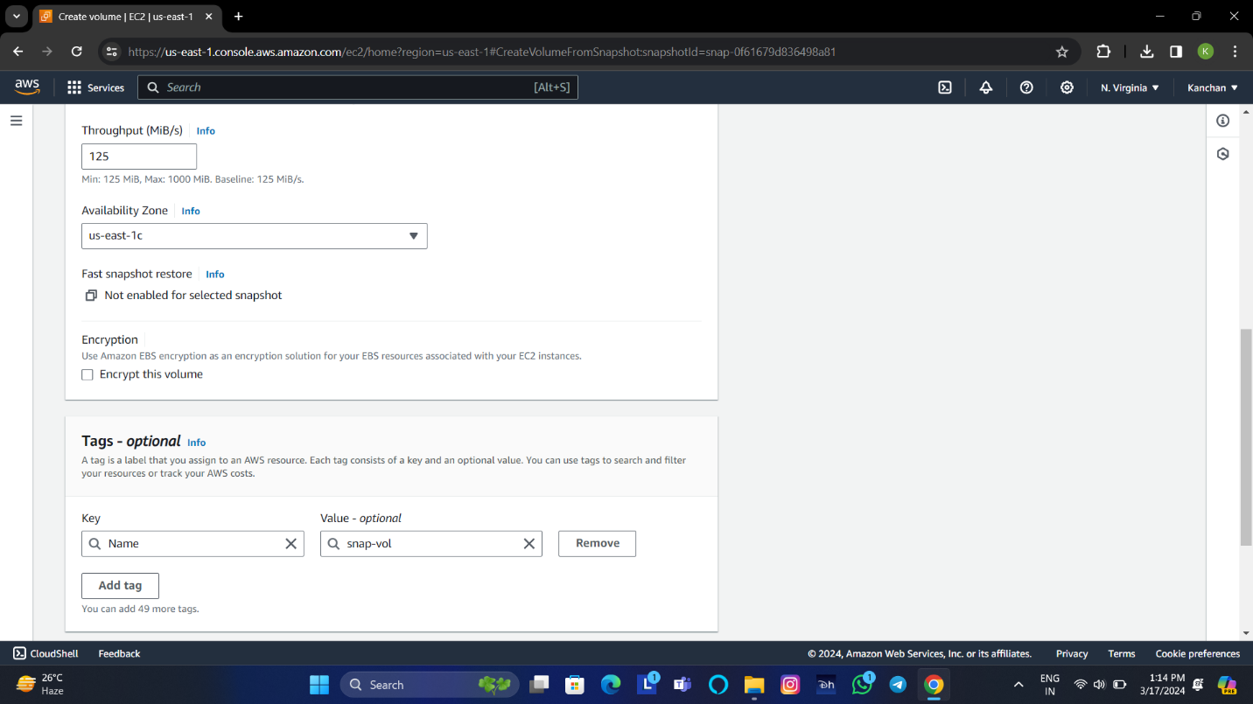

1. Edit the **tags**.

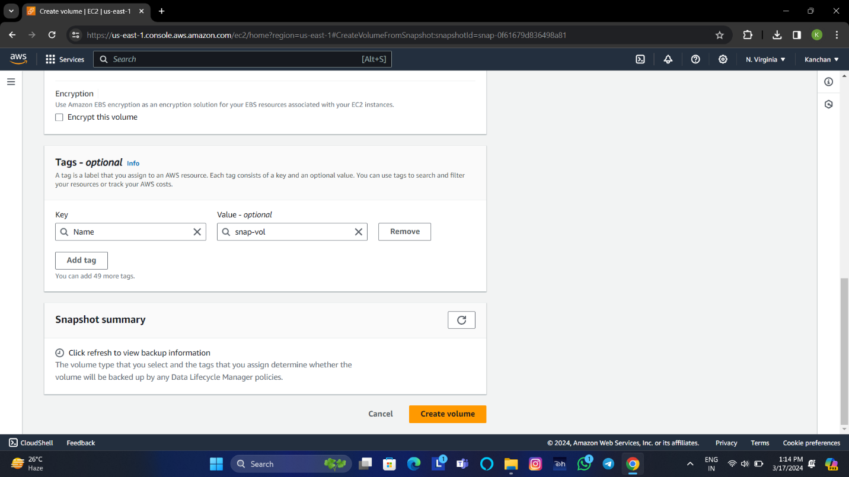

8.Choose **create Volume**.

8. Go to EC2 console, create a new instance in the same avilability zone of the volume.

9. **Stop** the instance.

10.On the elastic block store volumes menu , select root volume, then choose **Actions** and choose **detach volume**.

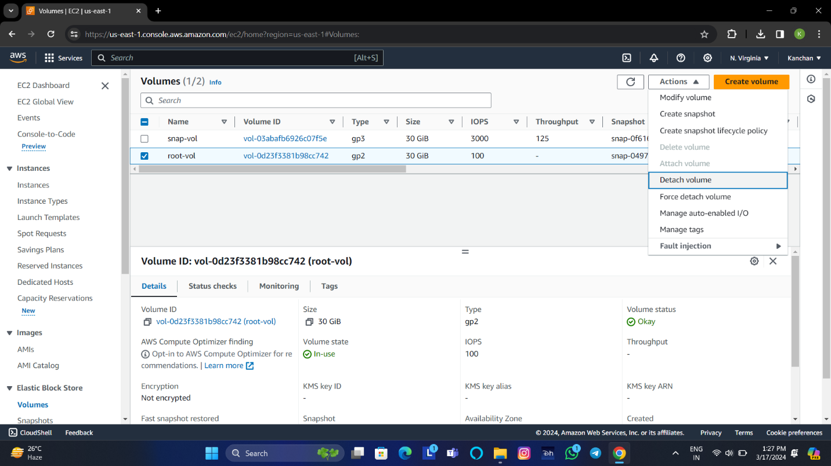

11. Select the snap-vol, choose **Actions** > **Attach volume**.

12. On the attach volume page, choose instance name and give the device name of root volume **(/dev/sda1)**.

13.Choose **Attach volume**.

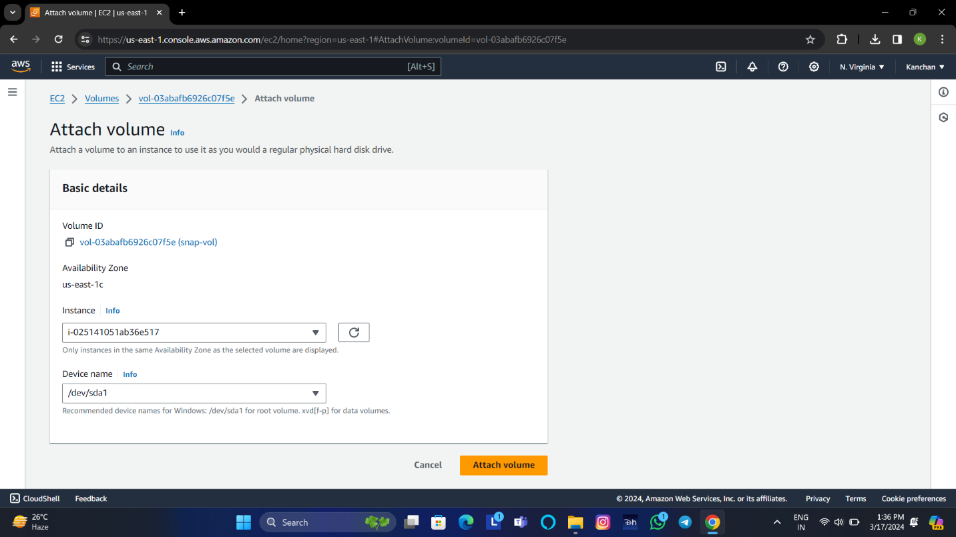

14. Select the instance,and see the new attached volume.

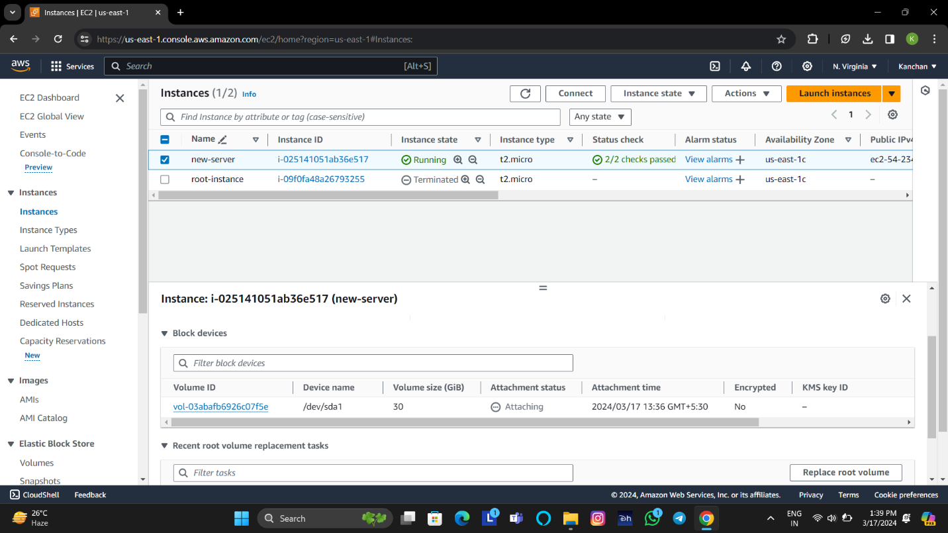

**EC2-user Practical Kanchan Pal**